**900-5500 MHz PRACTICAL VALUES**

**900 MHz, 15 (0.05 lambda)**

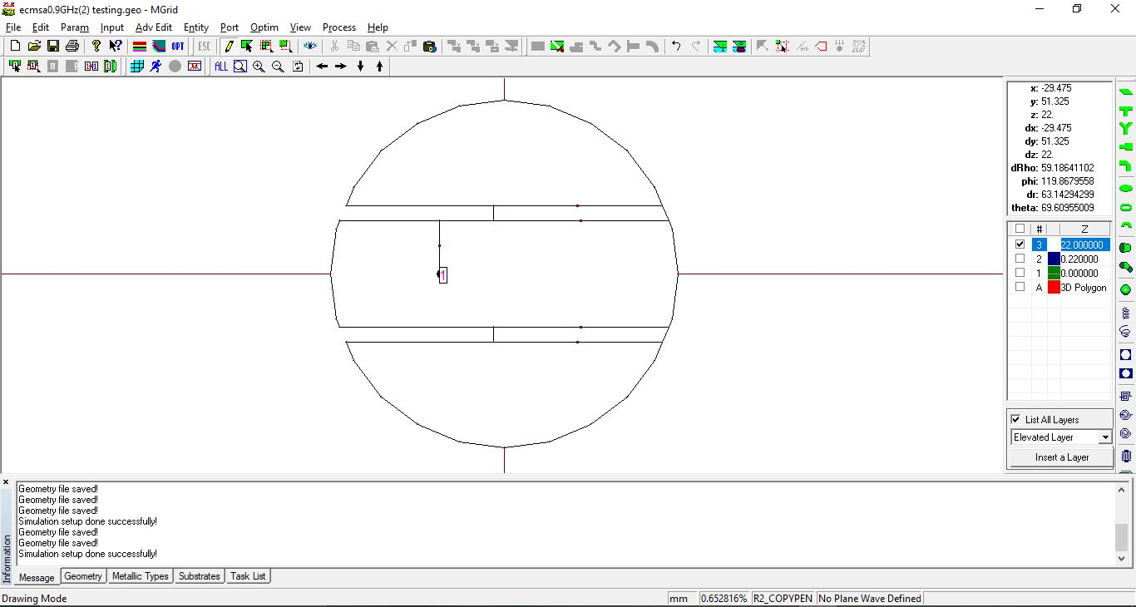

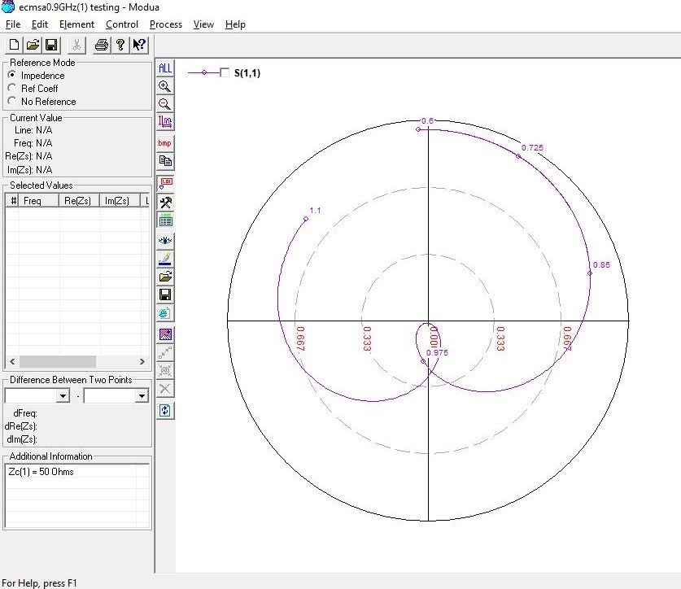

**900 MHz, 22 (0.07 lambda)**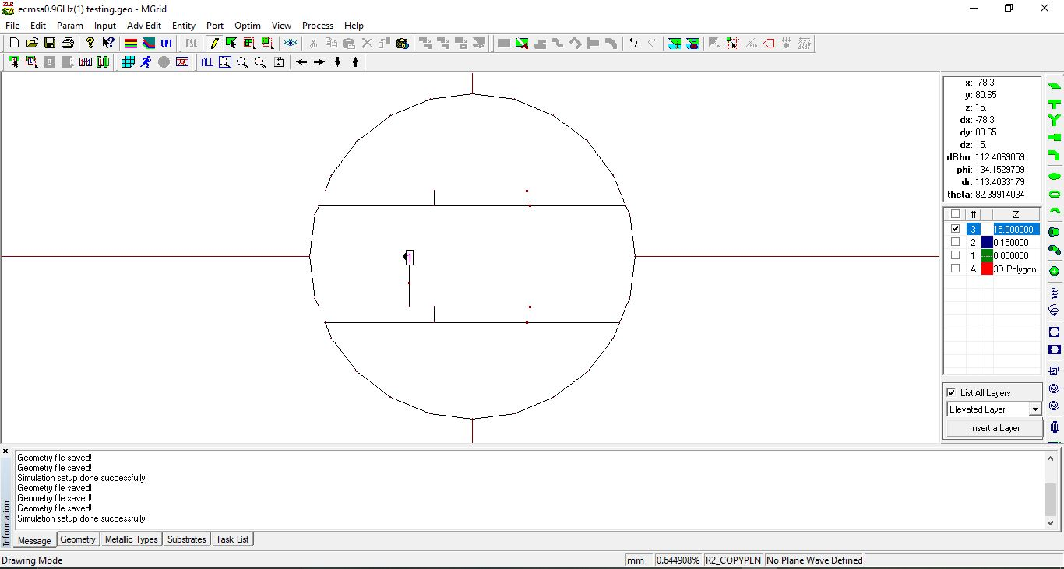

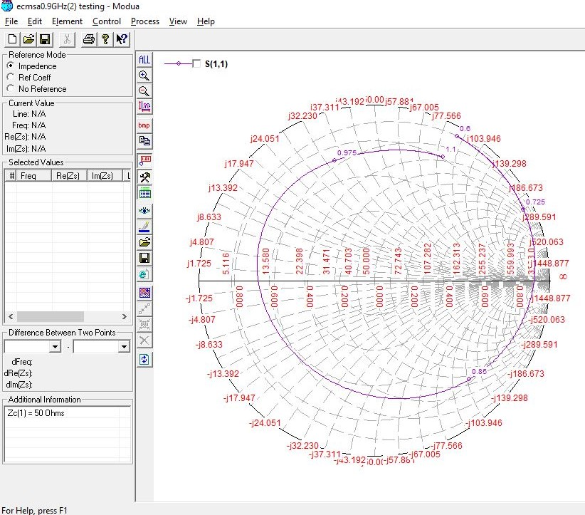

**1500 MHz, 10 (0.05 lambda)**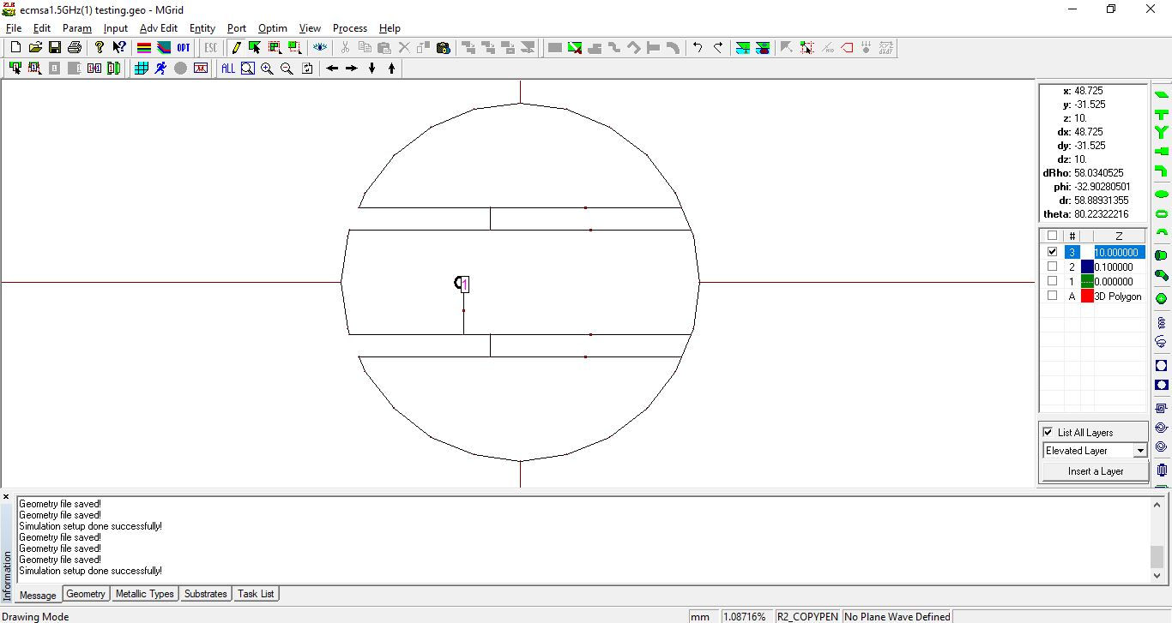

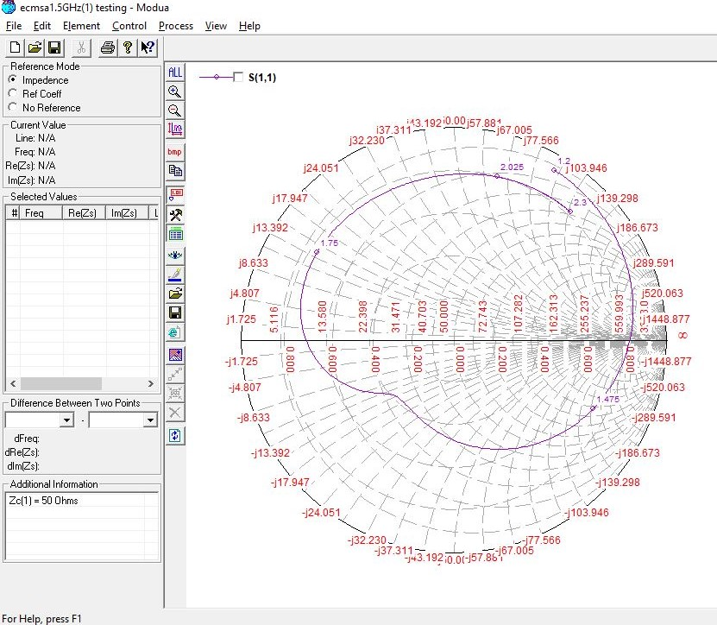

**1500 MHz, 10 (0.05 lambda) OPTIMIZED**

Initial Value:- Feed position : **-16mm**, Slot Length : **40mm**

Optimized Value:- Feed position: **-15mm**, Slot Length: **37mm**

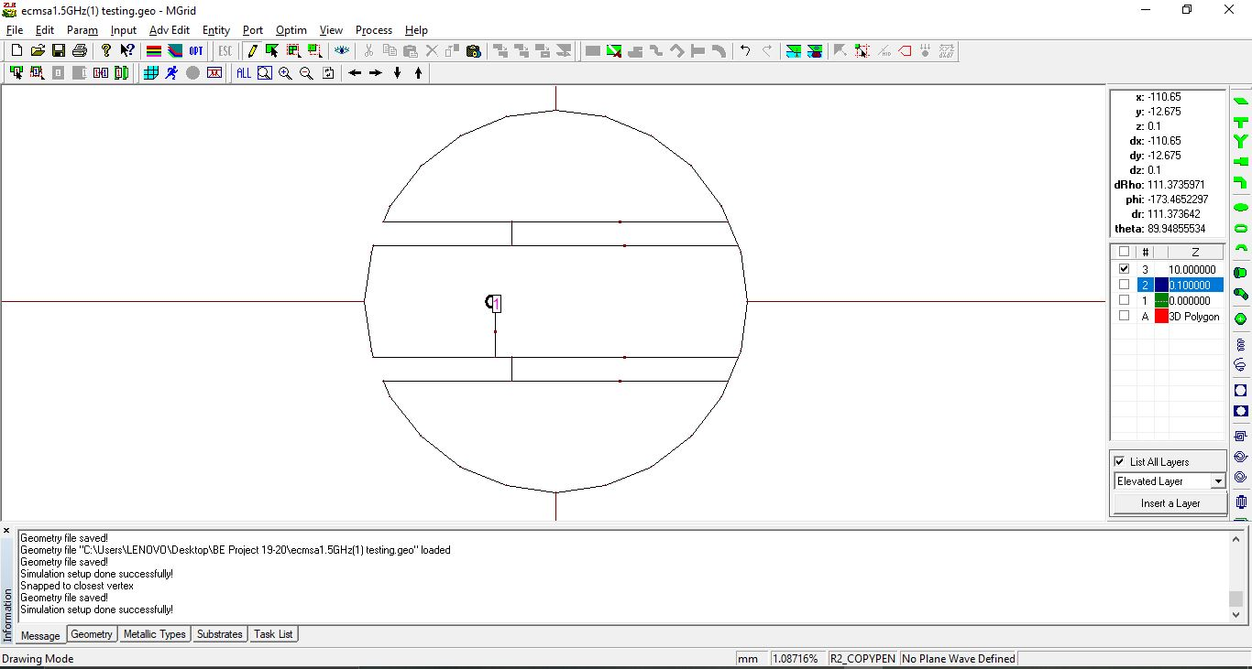

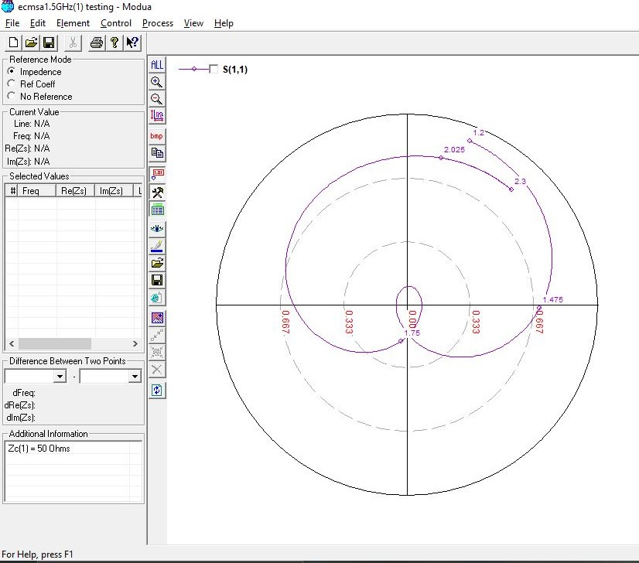

**1500 MHz, 14 (0.07 lambda)**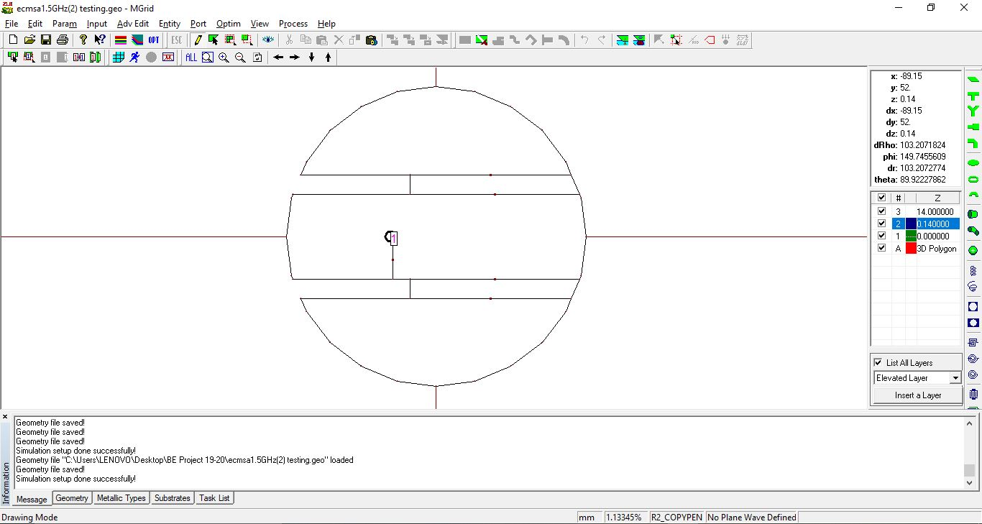

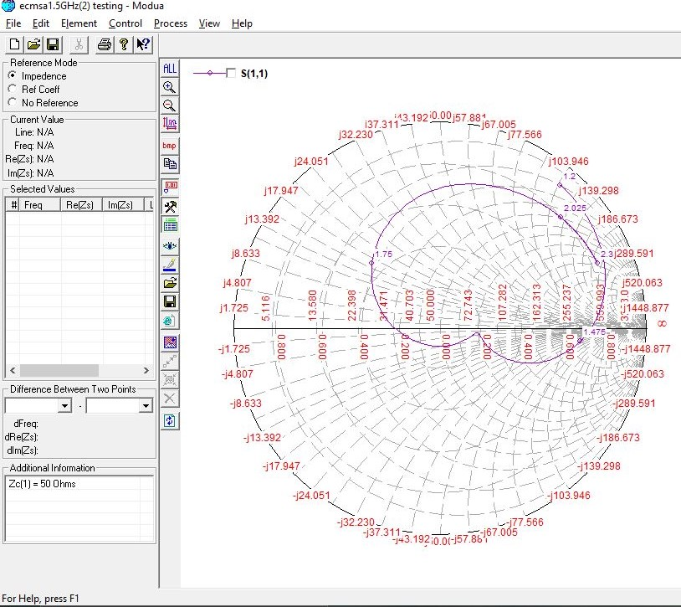

**1500, 14 (0.07 lambda) OPTIMIZED**

Initial Value:- Slot Length: **38mm**

Optimized Value:- Slot Length: **36.5mm**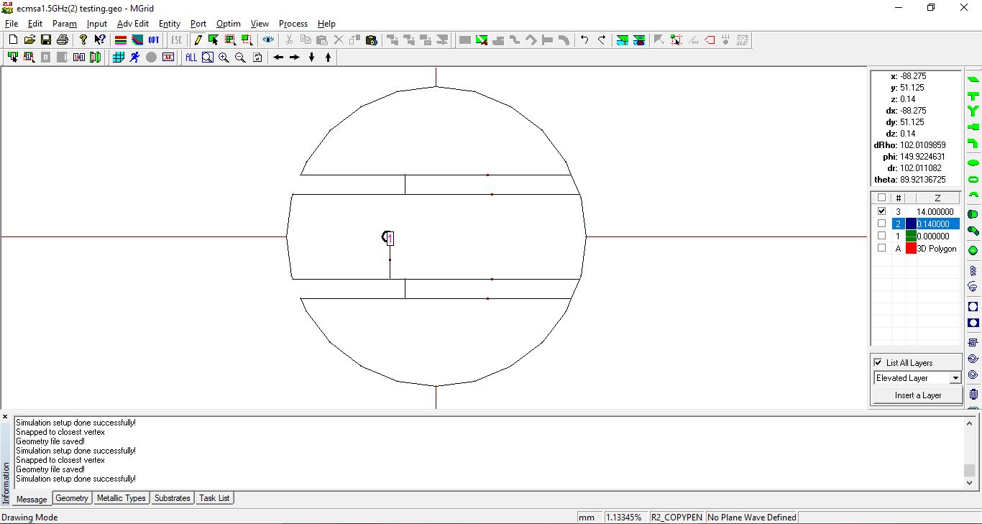

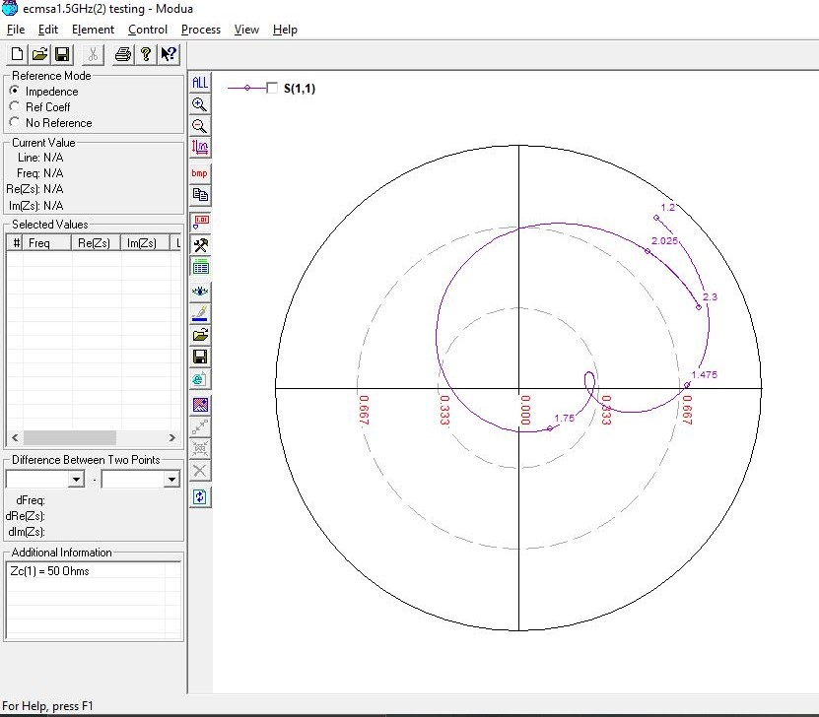

**2100 MHz, 7.5 (0.05 lambda)**

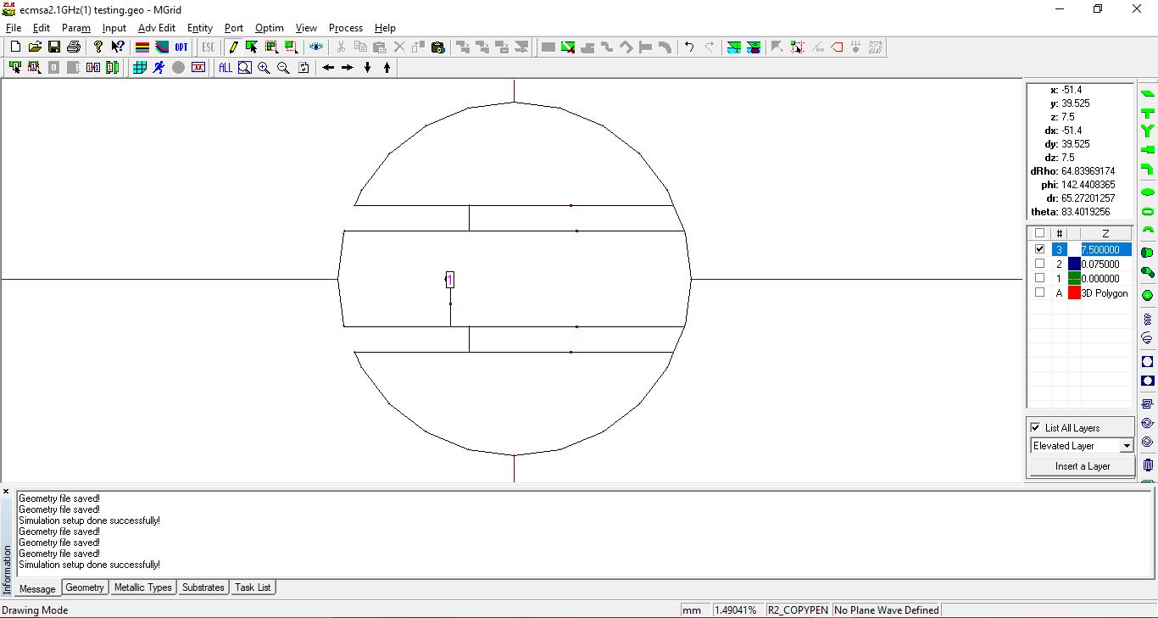

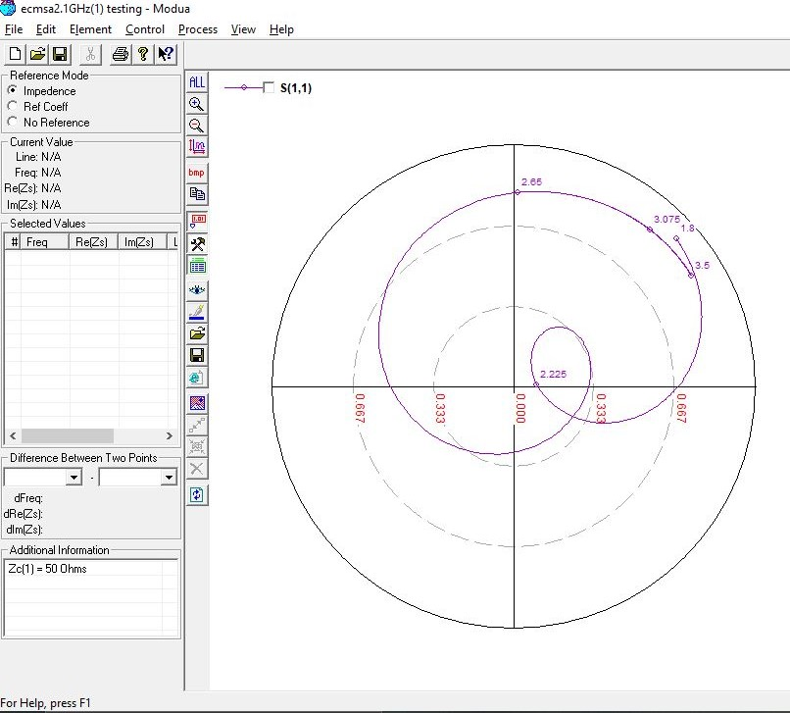

**2100 MHz, 9 (0.07 lambda)**

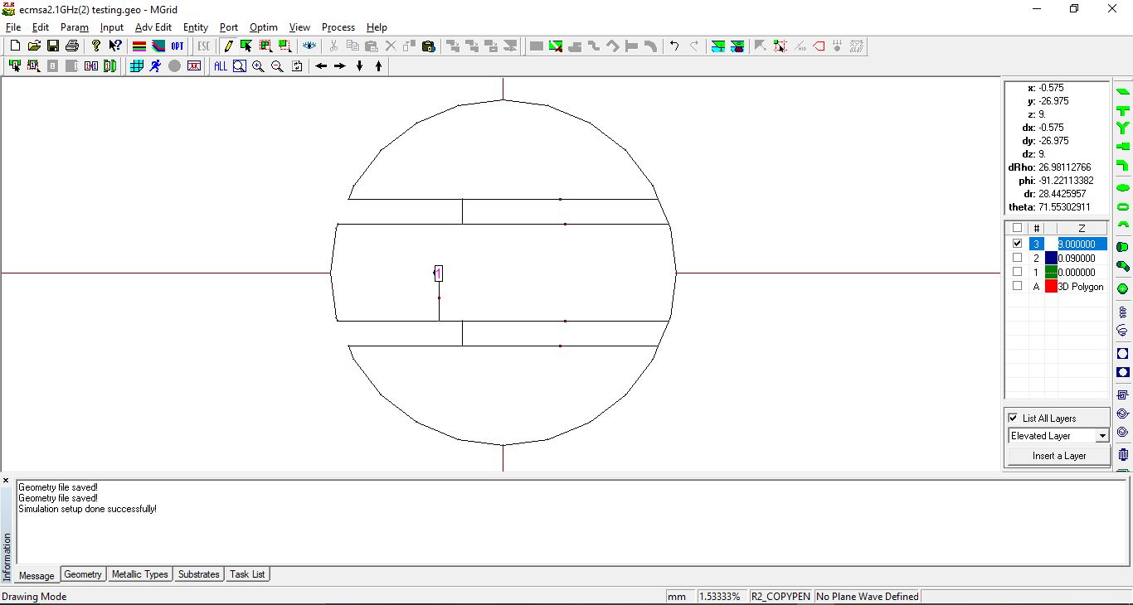

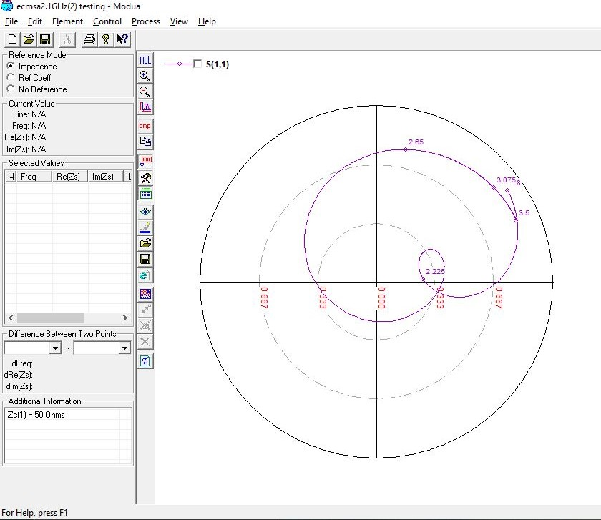

**2100, 9 (0.07 lambda) OPTIMIZED**

Initial Value:- Feed Position: **-13mm**, Slot Length: **26mm**

Optimized Value:- Feed Position: **-12mm**, Slot Length: **27mm**

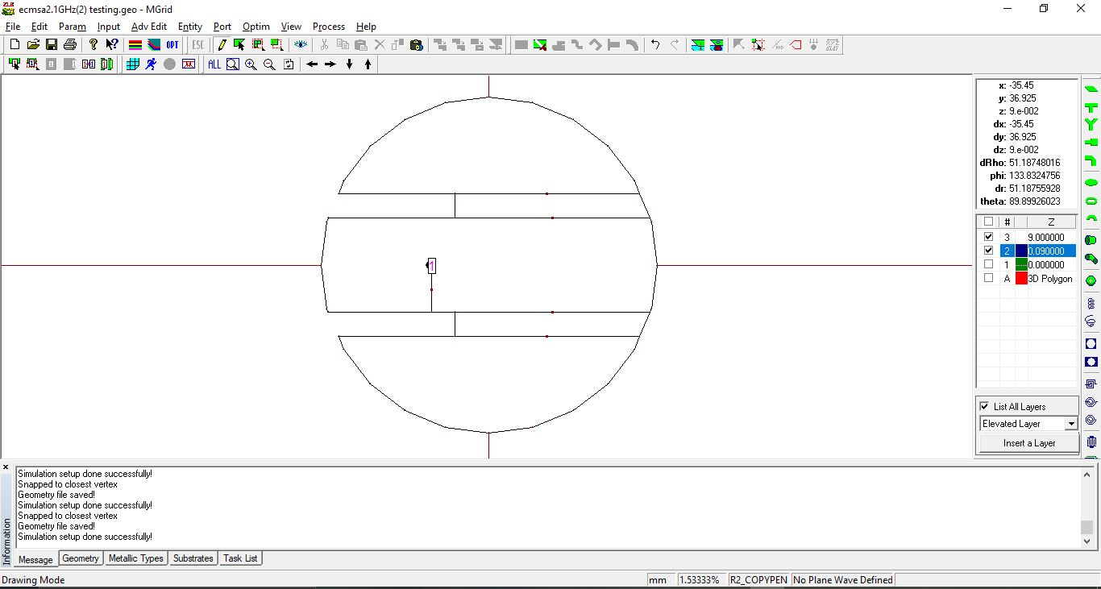

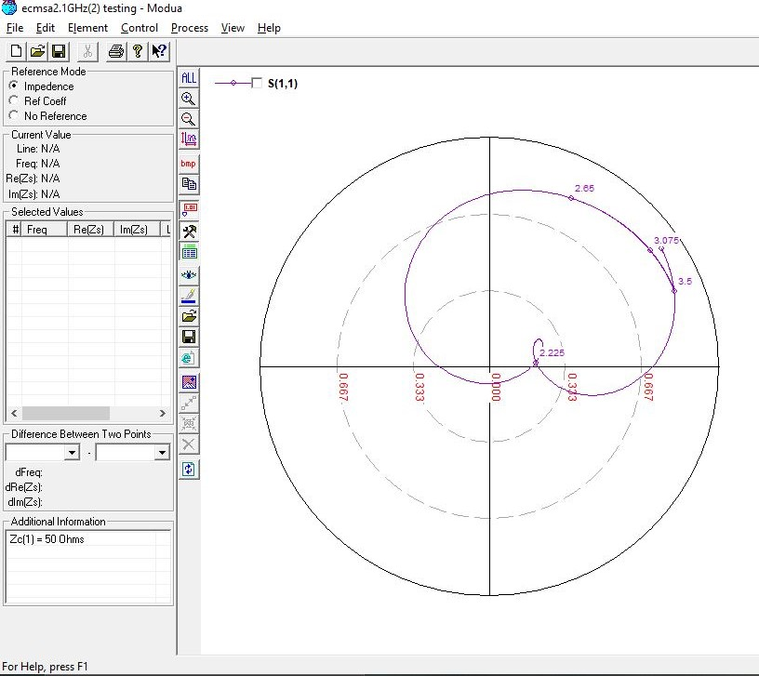

**2700 MHz, 6 (0.05 lambda)**

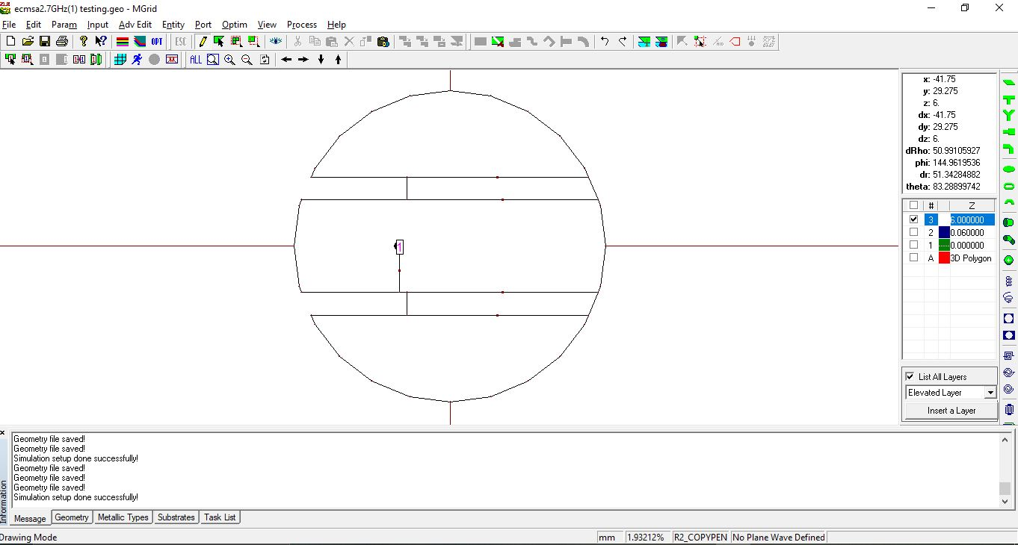

**Increase slot length**

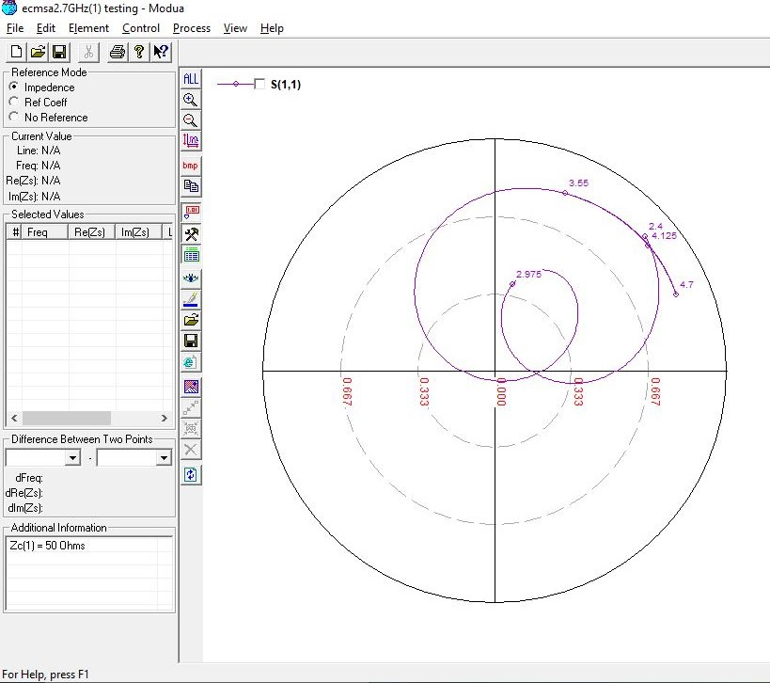

**2700 MHz, 6 (0.05 lambda) OPTIMIZED**

Initial Value:- Slot Length: **19.5mm**

Optimized Value:- Slot Length: **21mm**

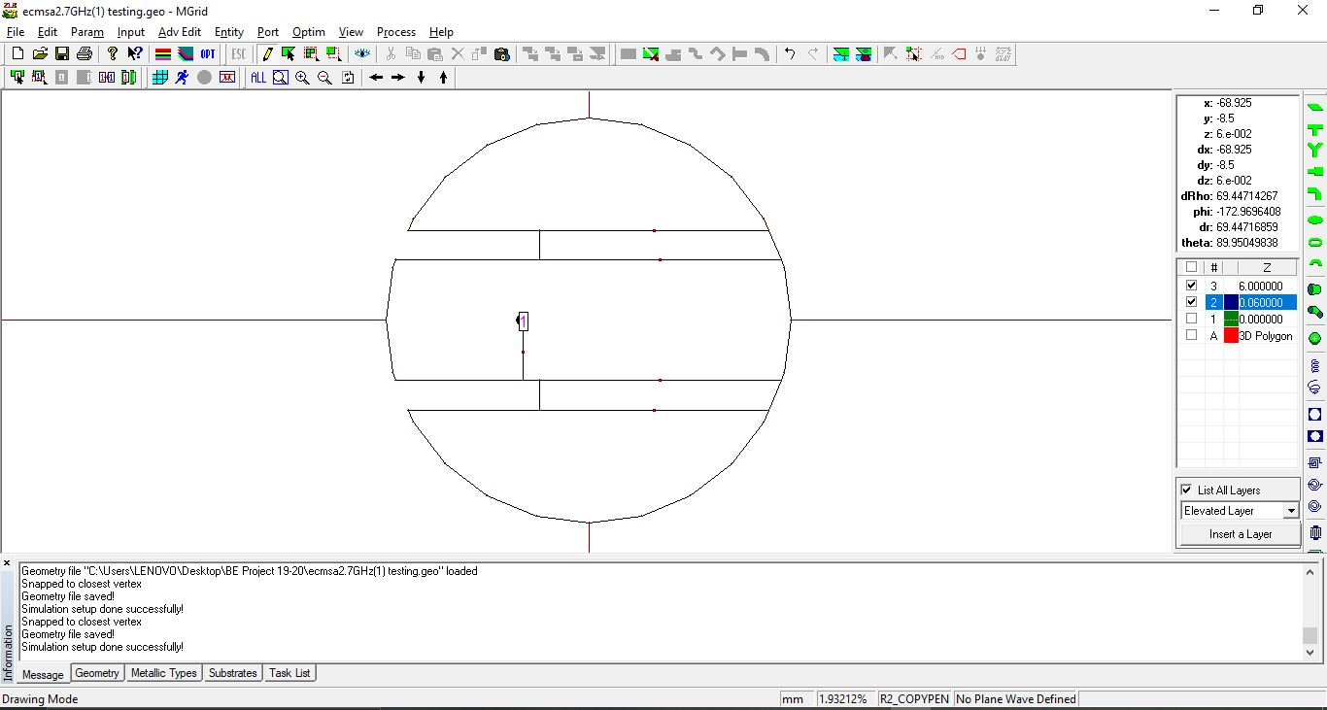

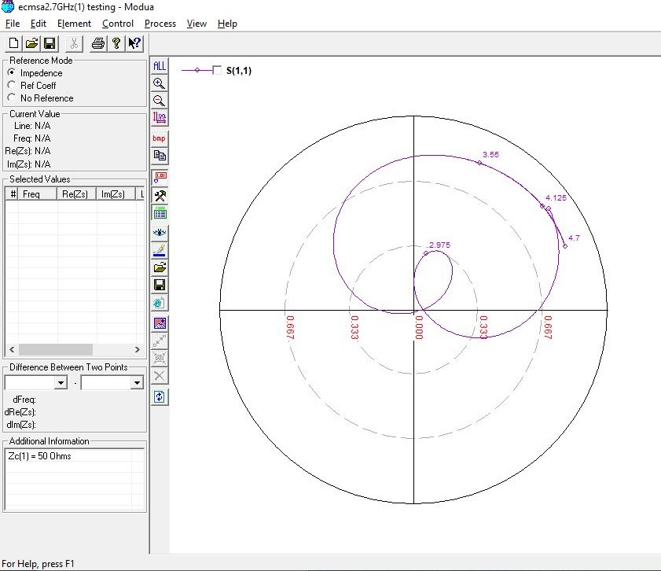

**2700 MHz, 7 (0.07 lambda)**



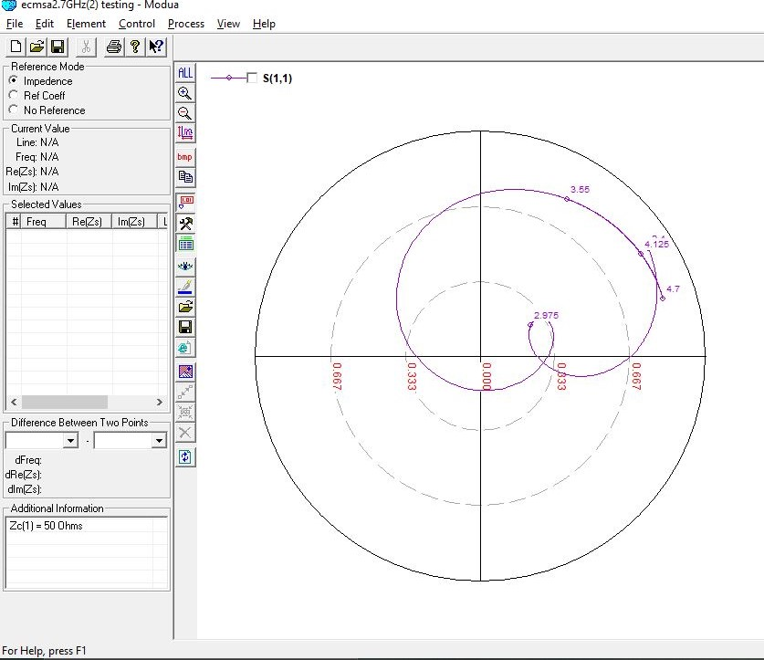

**3300 MHz, 5 (0.05 lambda)** 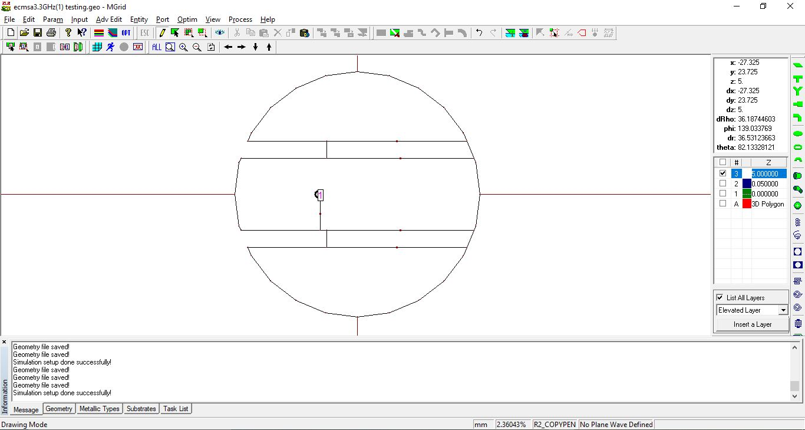

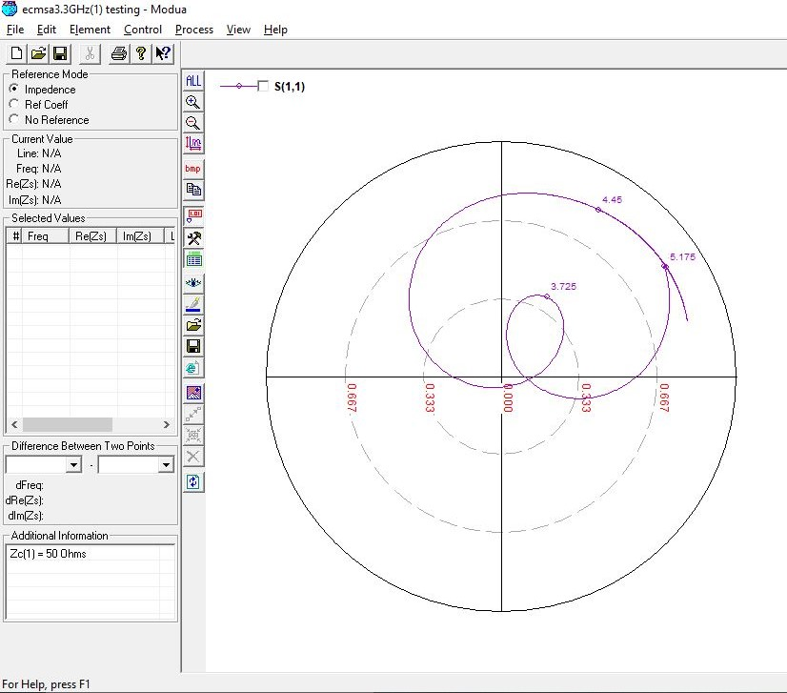

**3300 MHz, 5 (0.05 lambda) OPTIMIZED**

Initial Value:- Slot Length – **16.5mm**

Optimized Value:- Slot Length – **18mm**

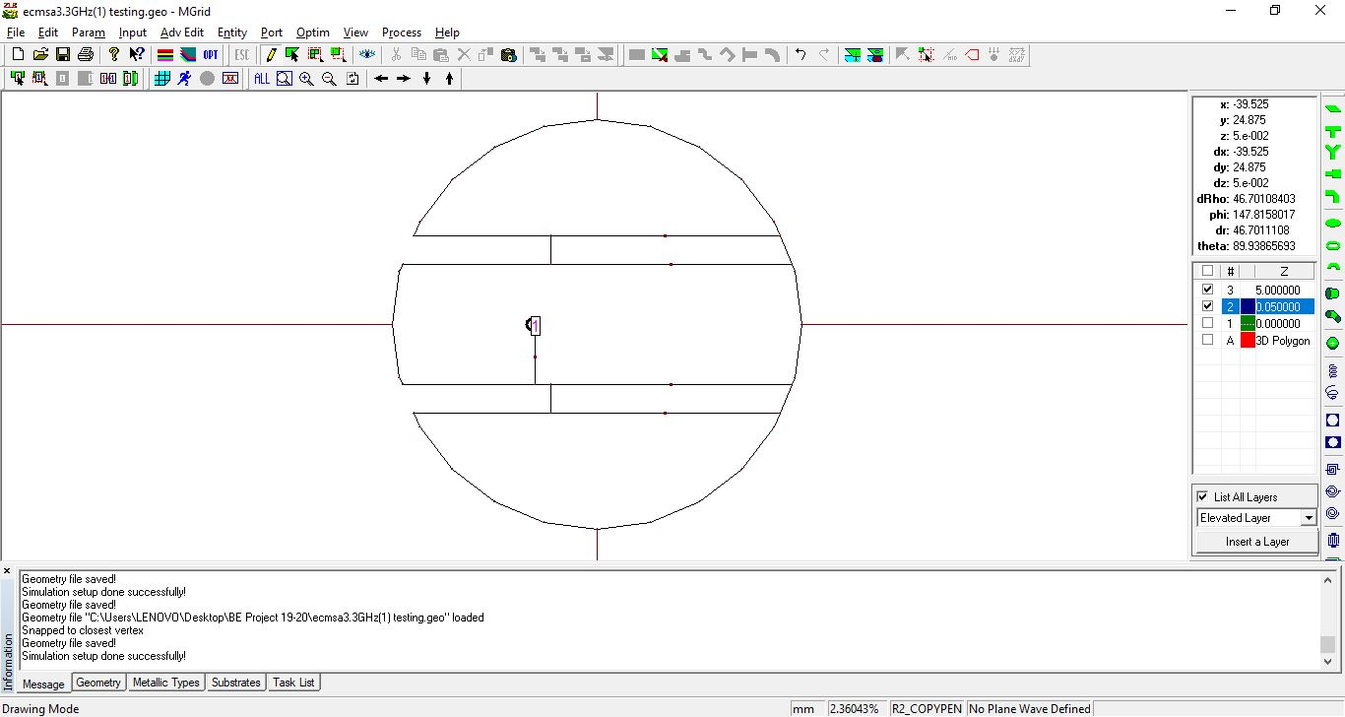

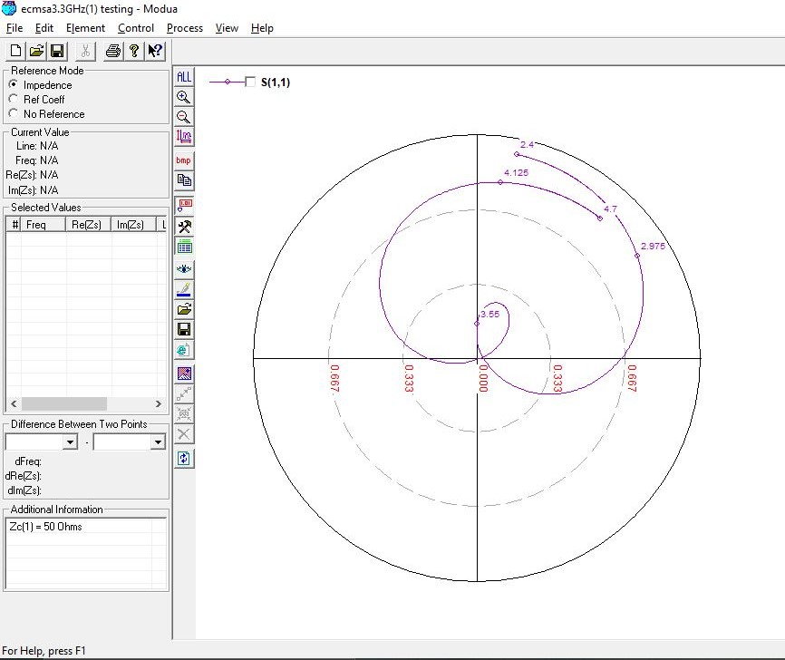

**3300 MHz, 6 (0.07 lambda)**

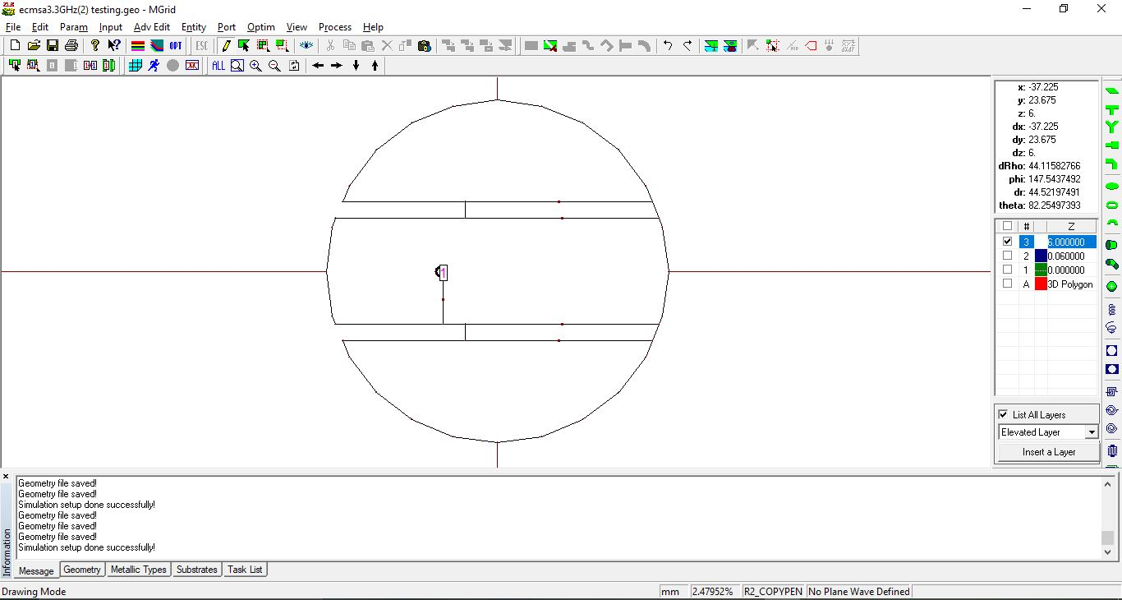

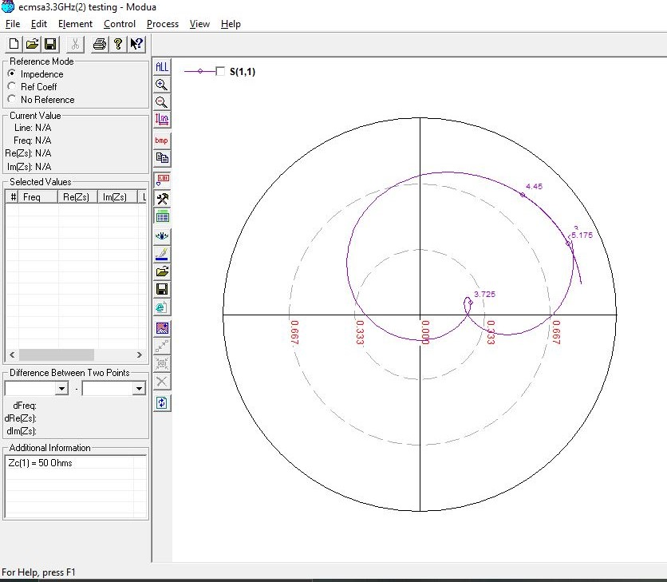

**3900 MHz, 5 (0.05 lambda)**

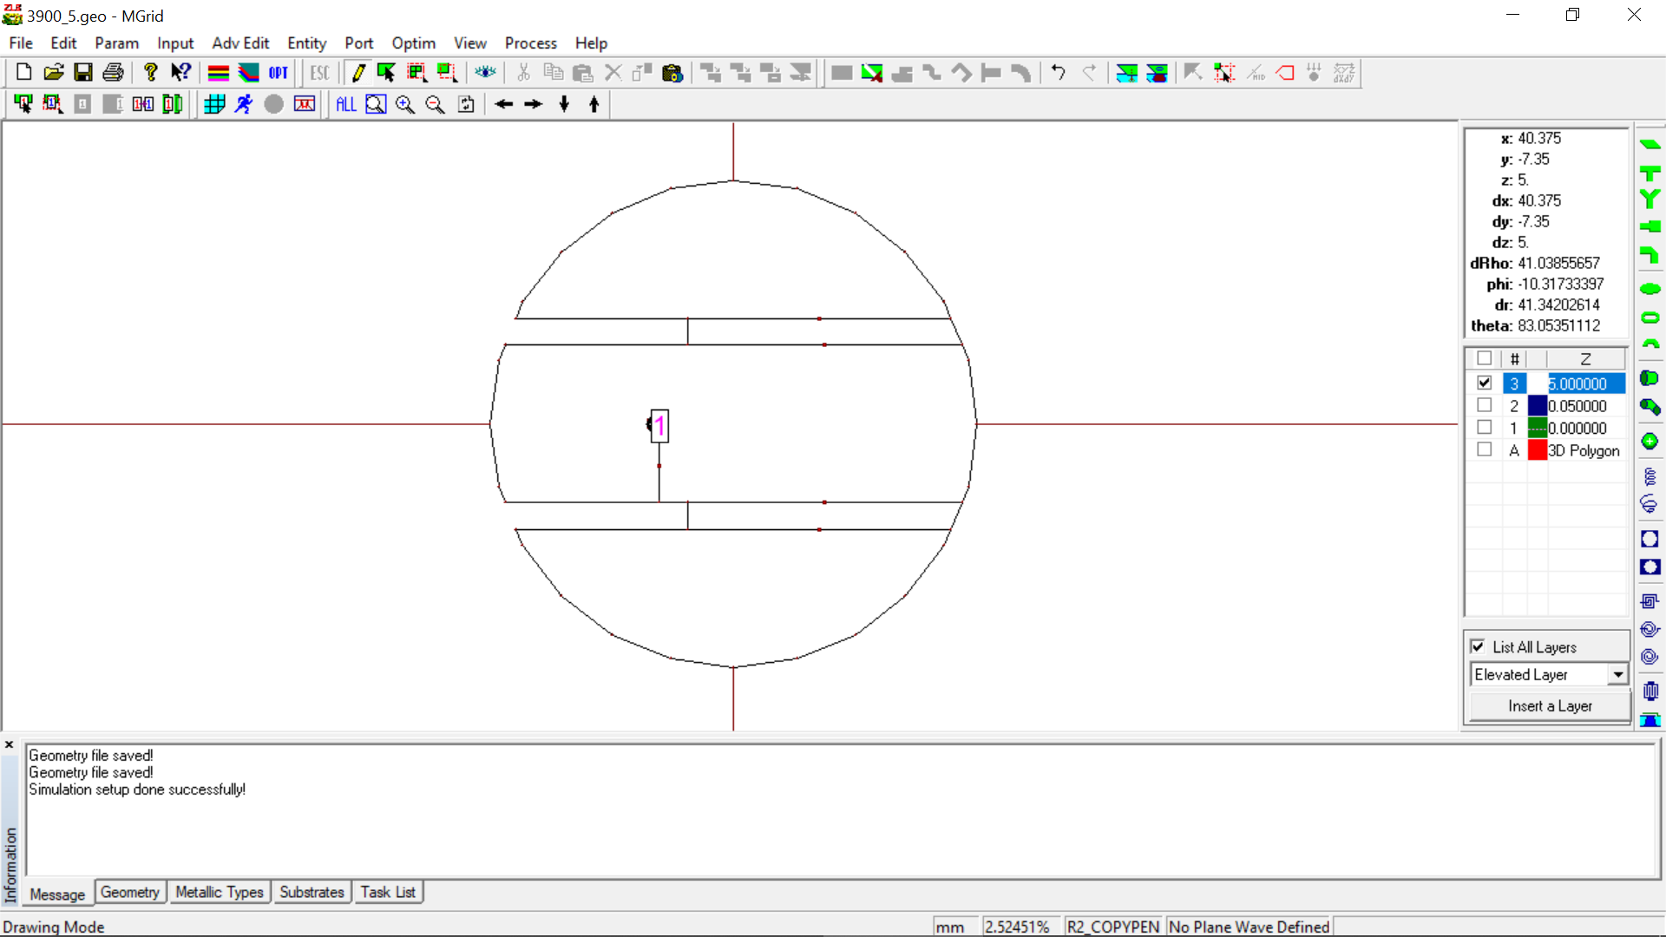

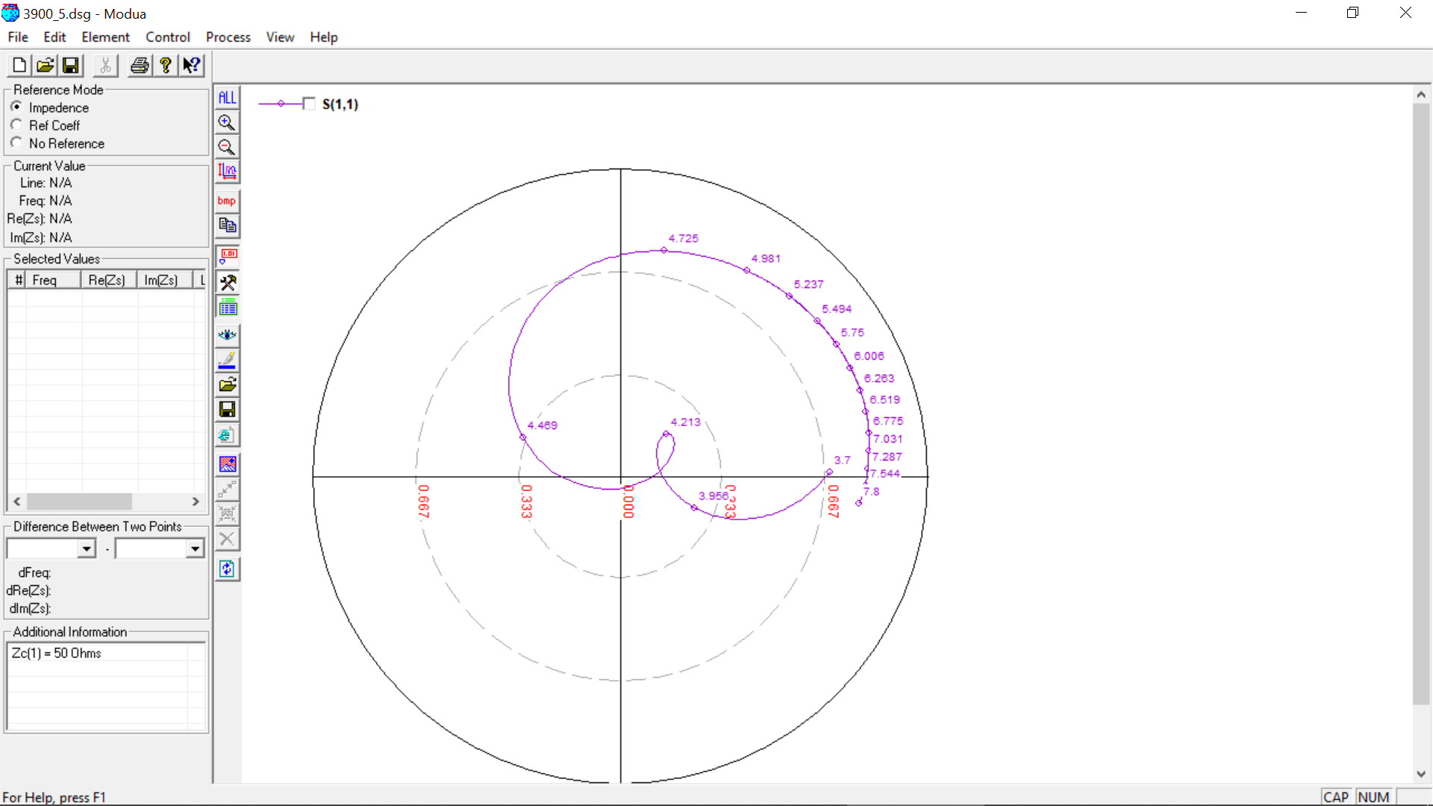

**3900 MHz, 5 (0.07 lambda)**

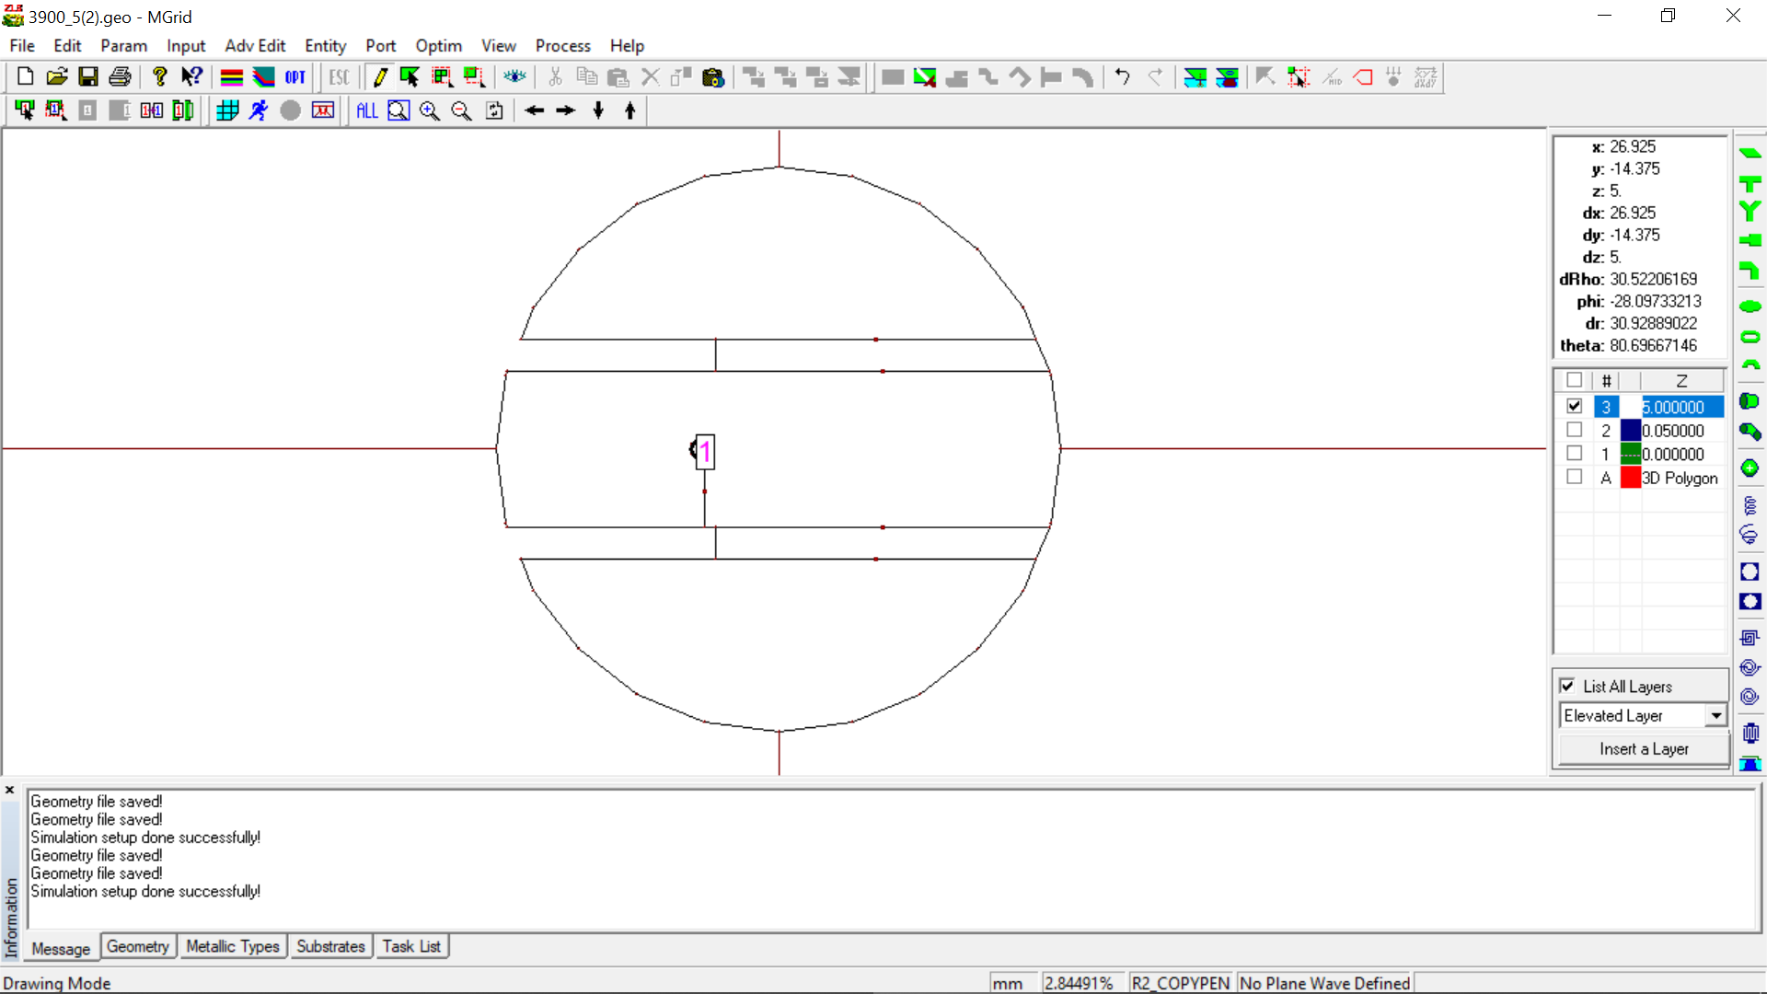

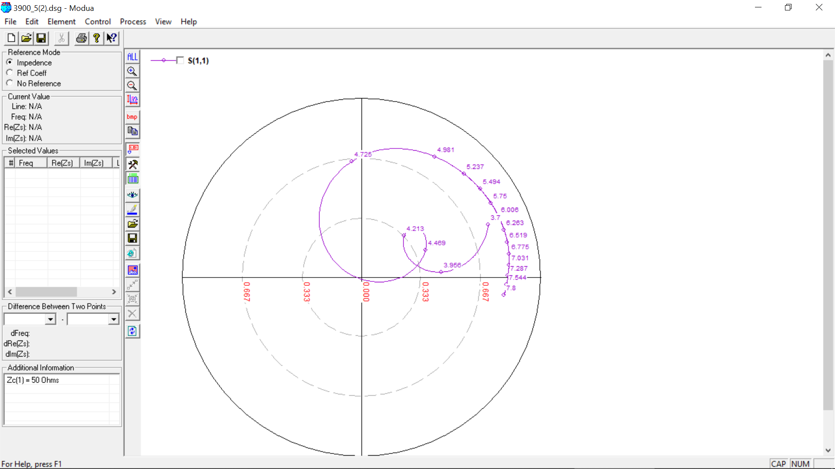

**3900 MHz, 5 (0.07 lambda) OPTIMIZED**

Initial Value: Slot Length = **14 mm**

Optimized Value: Slot Length = **14.5 mm**

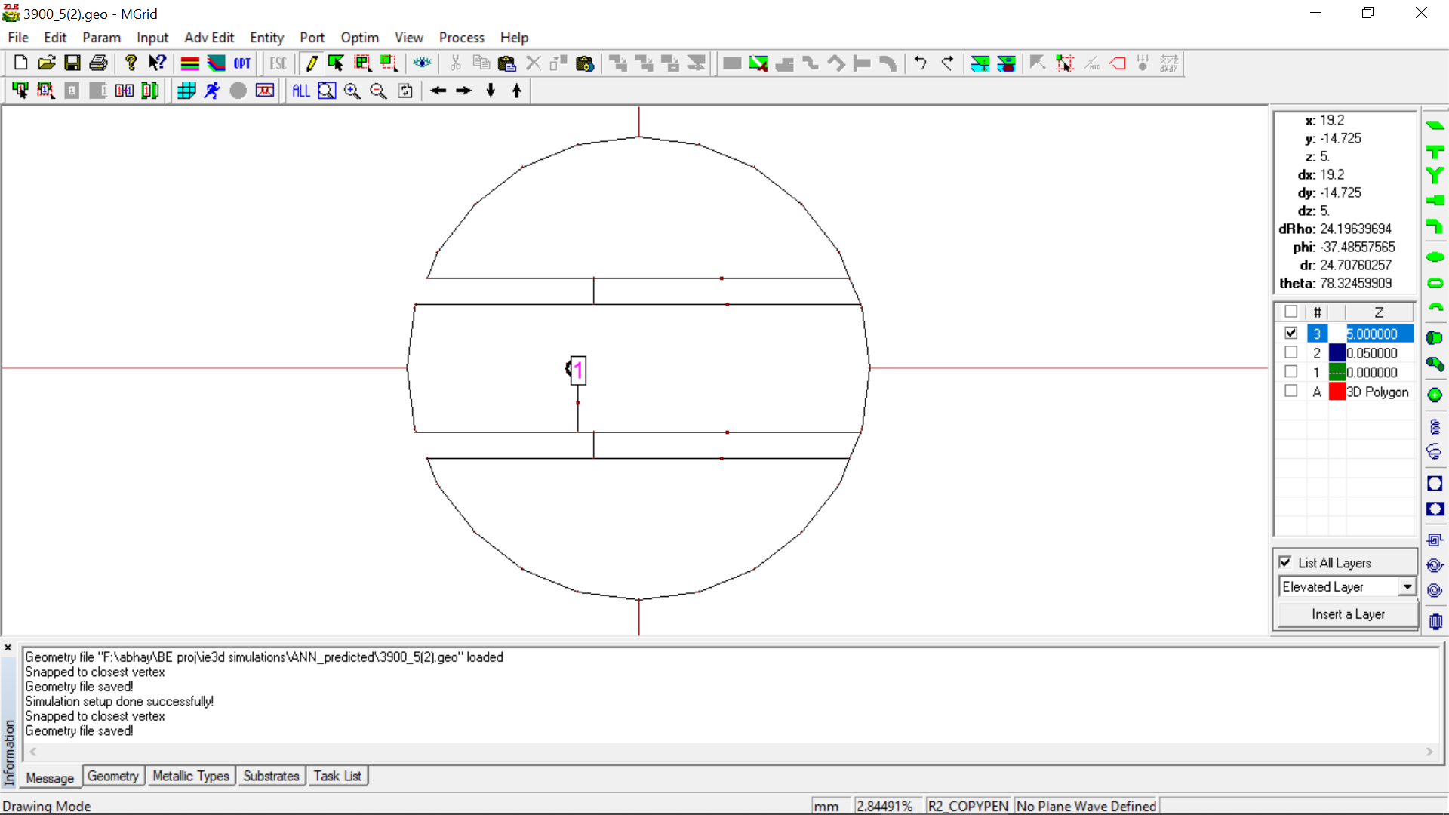

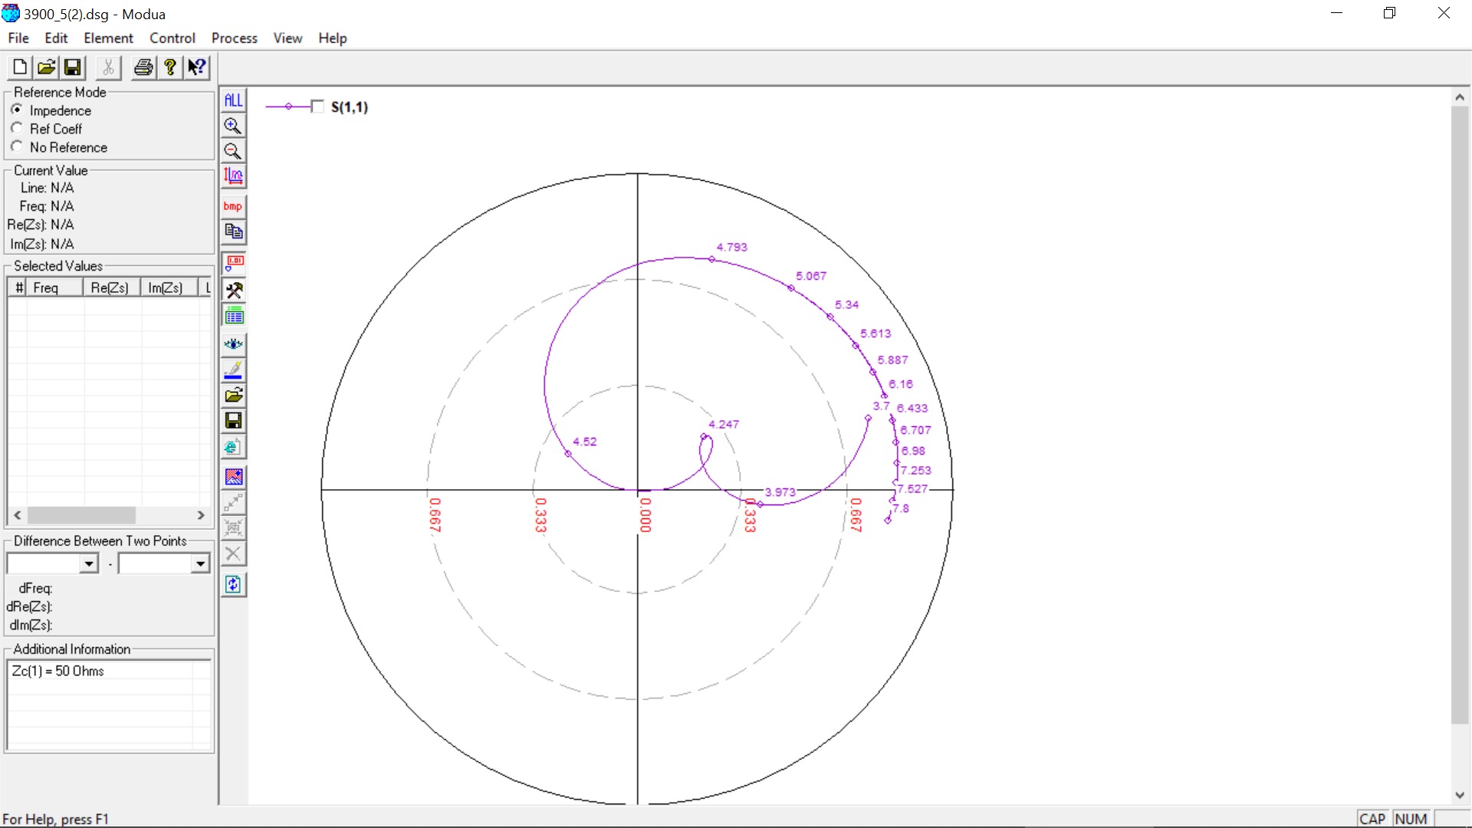

**4300 MHz, 4 (0.05 lambda)**

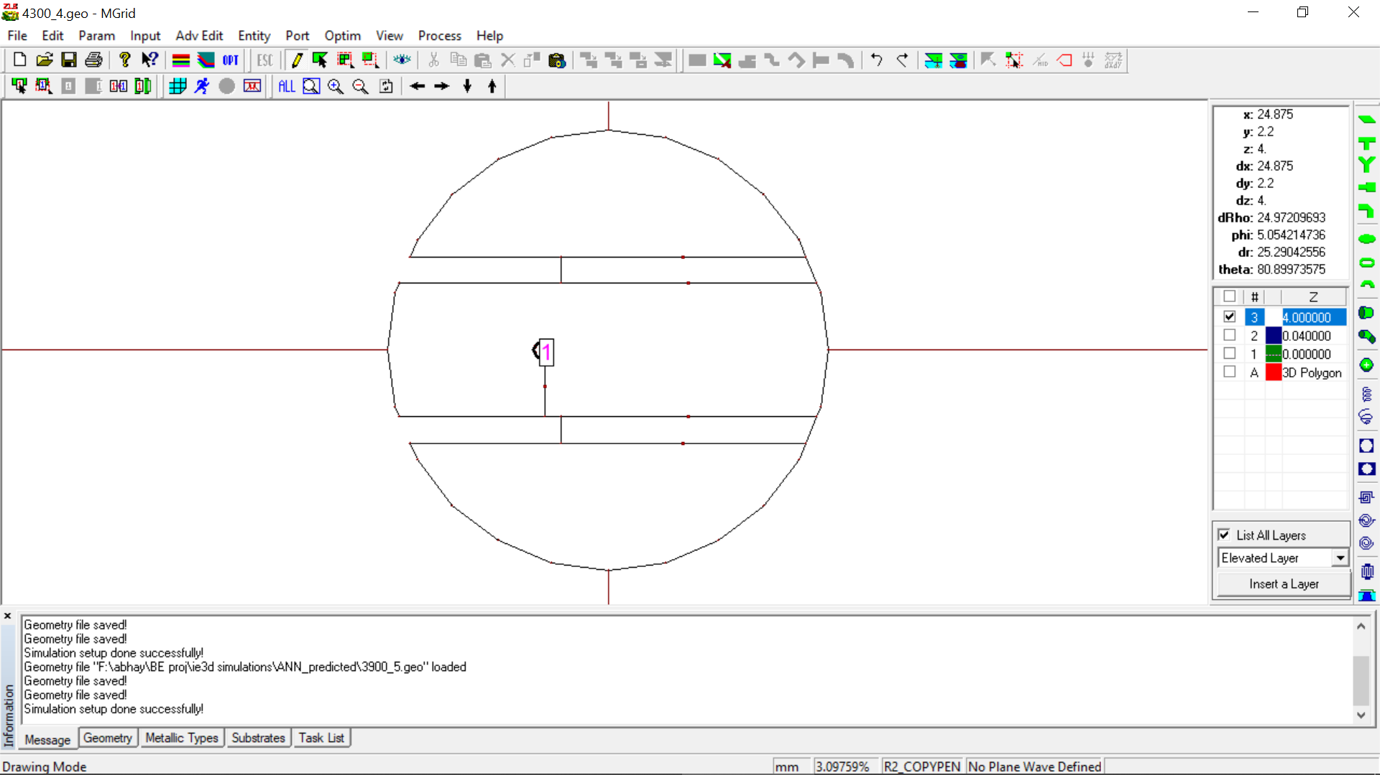

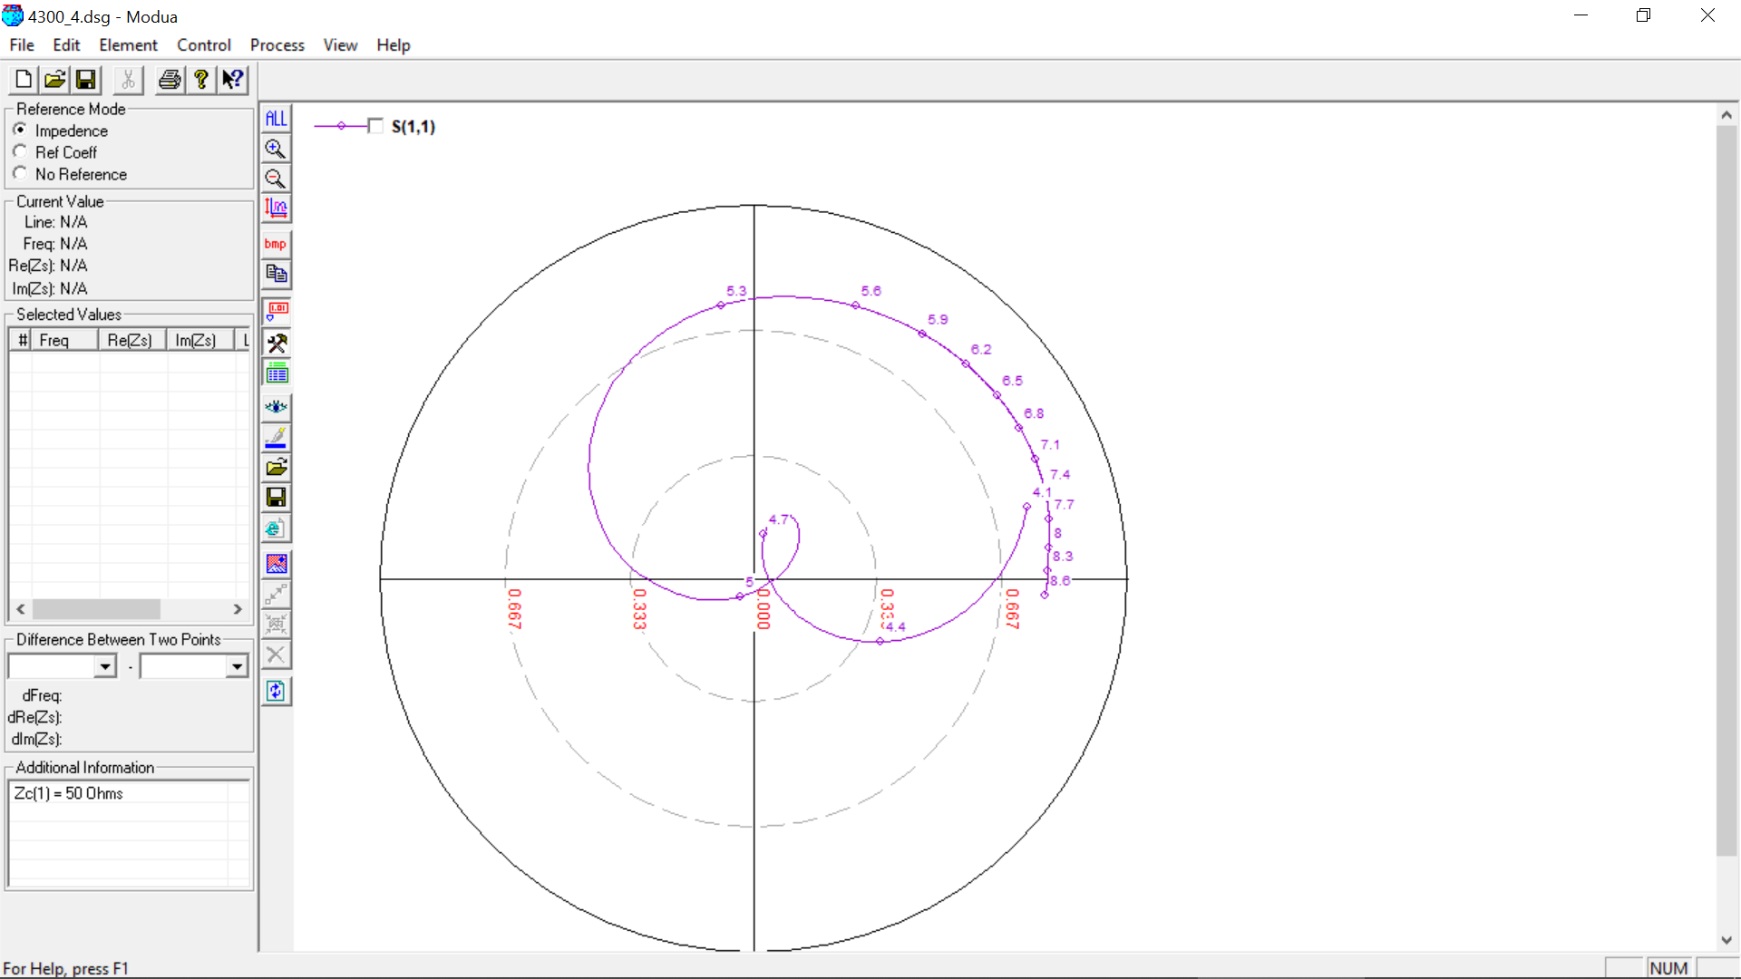

**4300 MHz, 5 (0.07 lambda)**

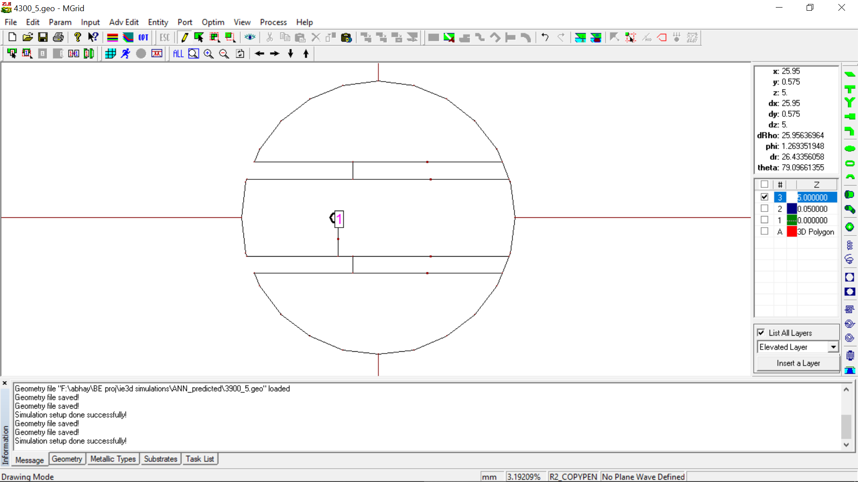

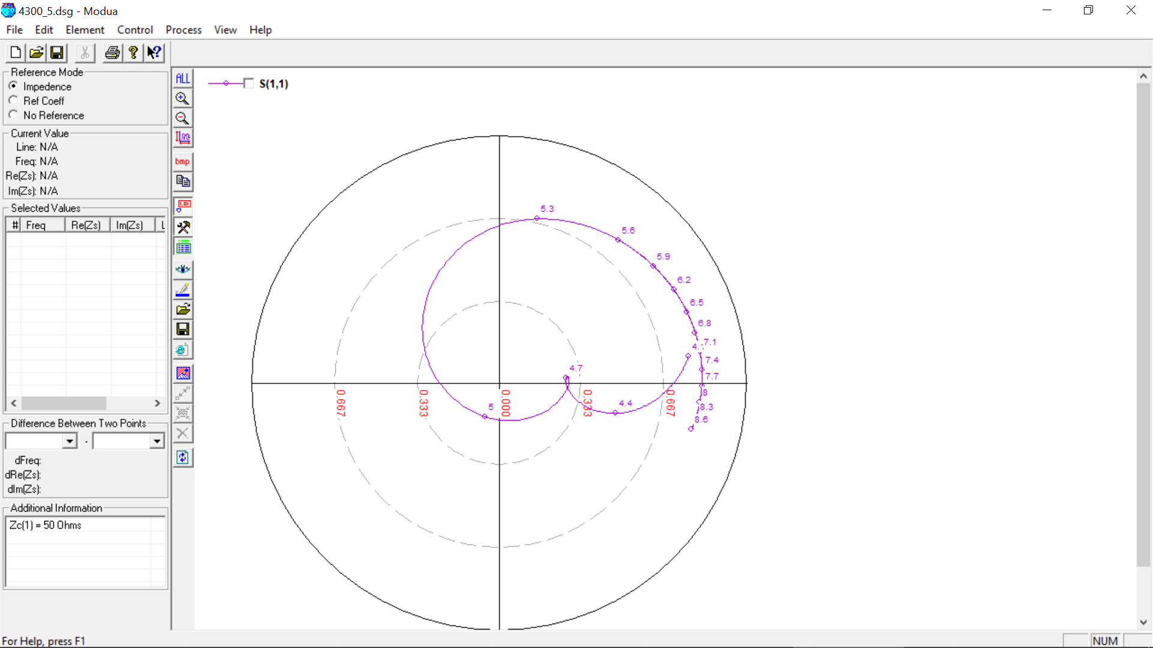

**4900 MHz, 4 (0.05 lambda)**

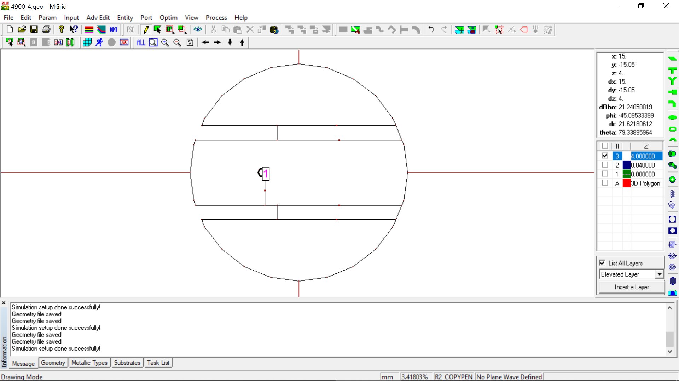

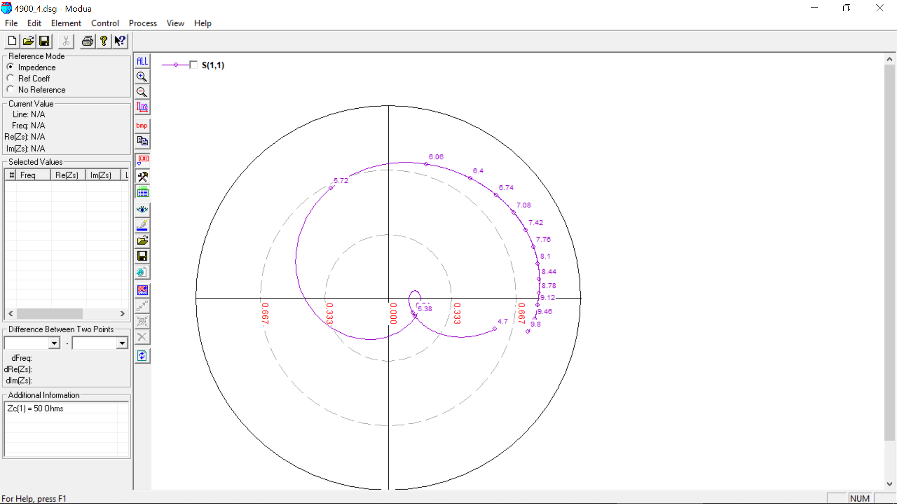

**4900 MHz, 4 (0.07 lambda)**

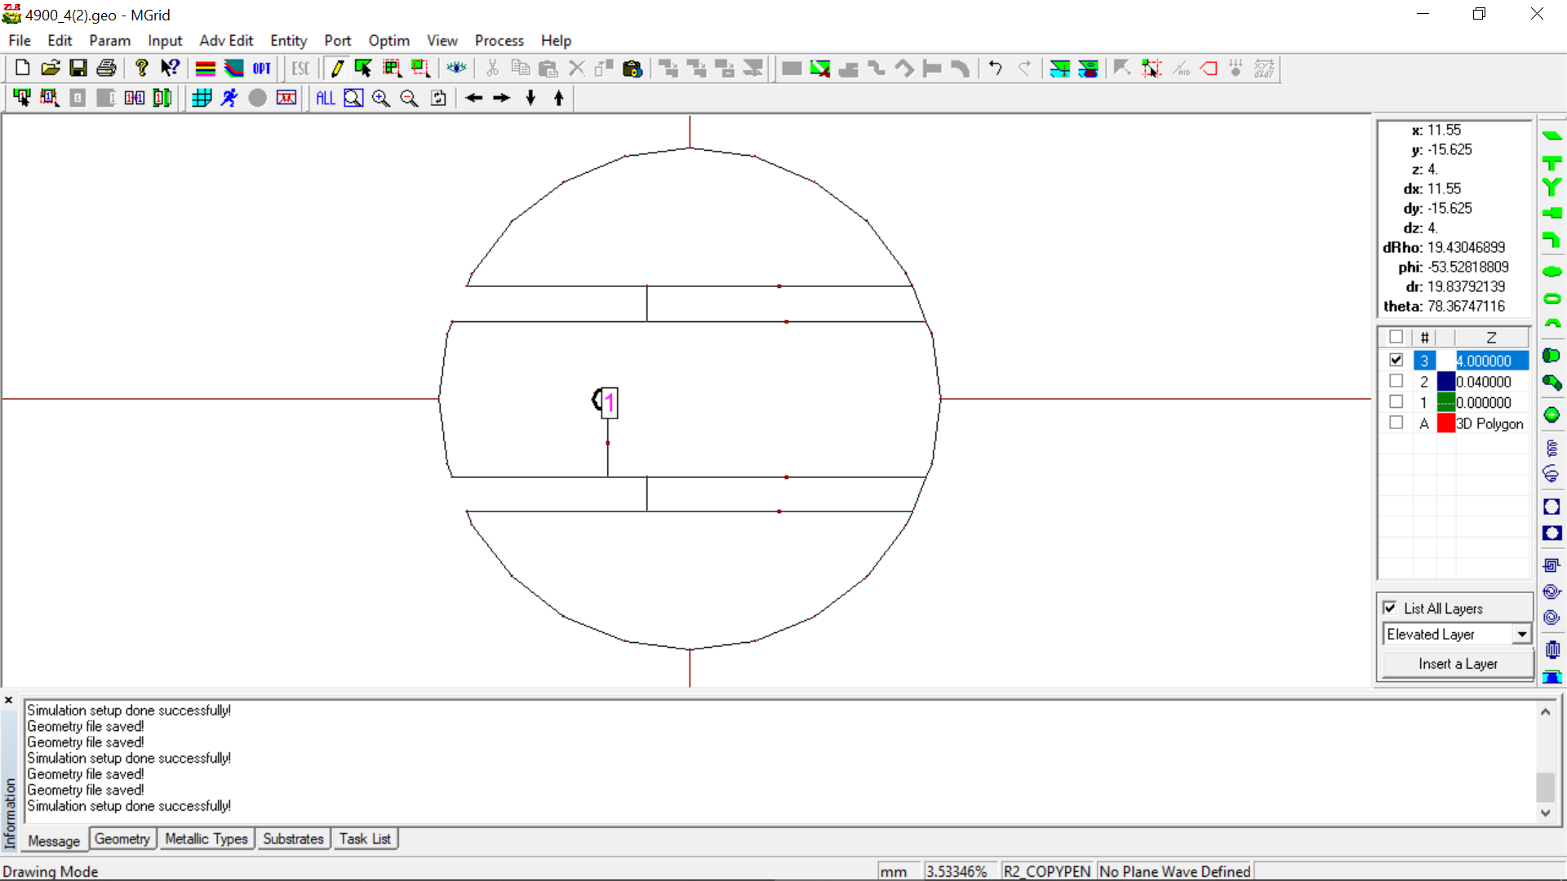

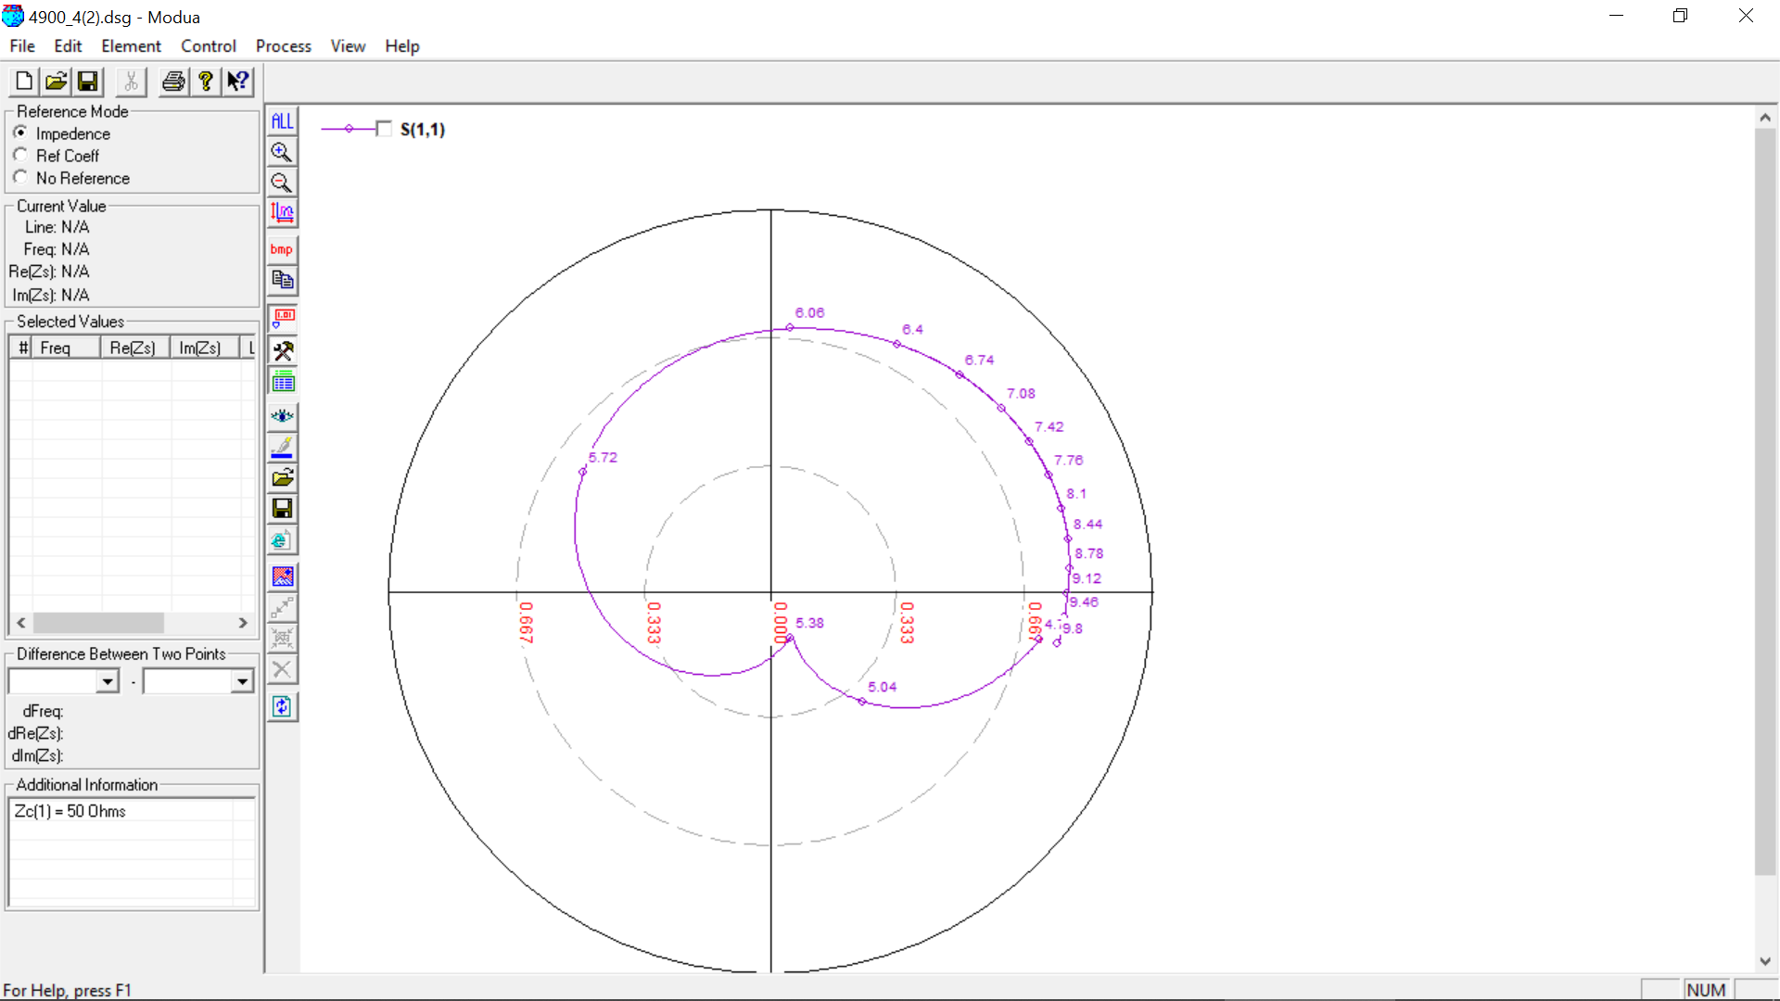

**4900 MHz, 4 (0.07 lambda) OPTIMIZED**

Initial Value: Slot Length = **12 mm**

Optimized Value: Slot Length = **11.5 mm**

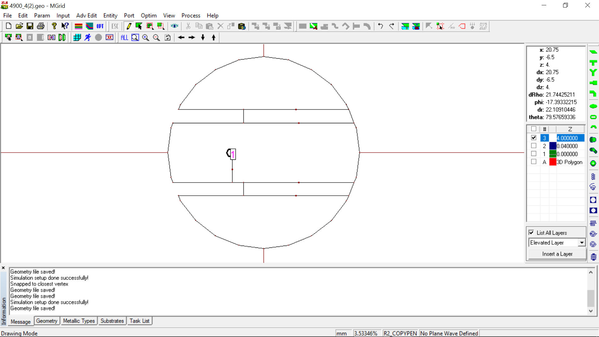

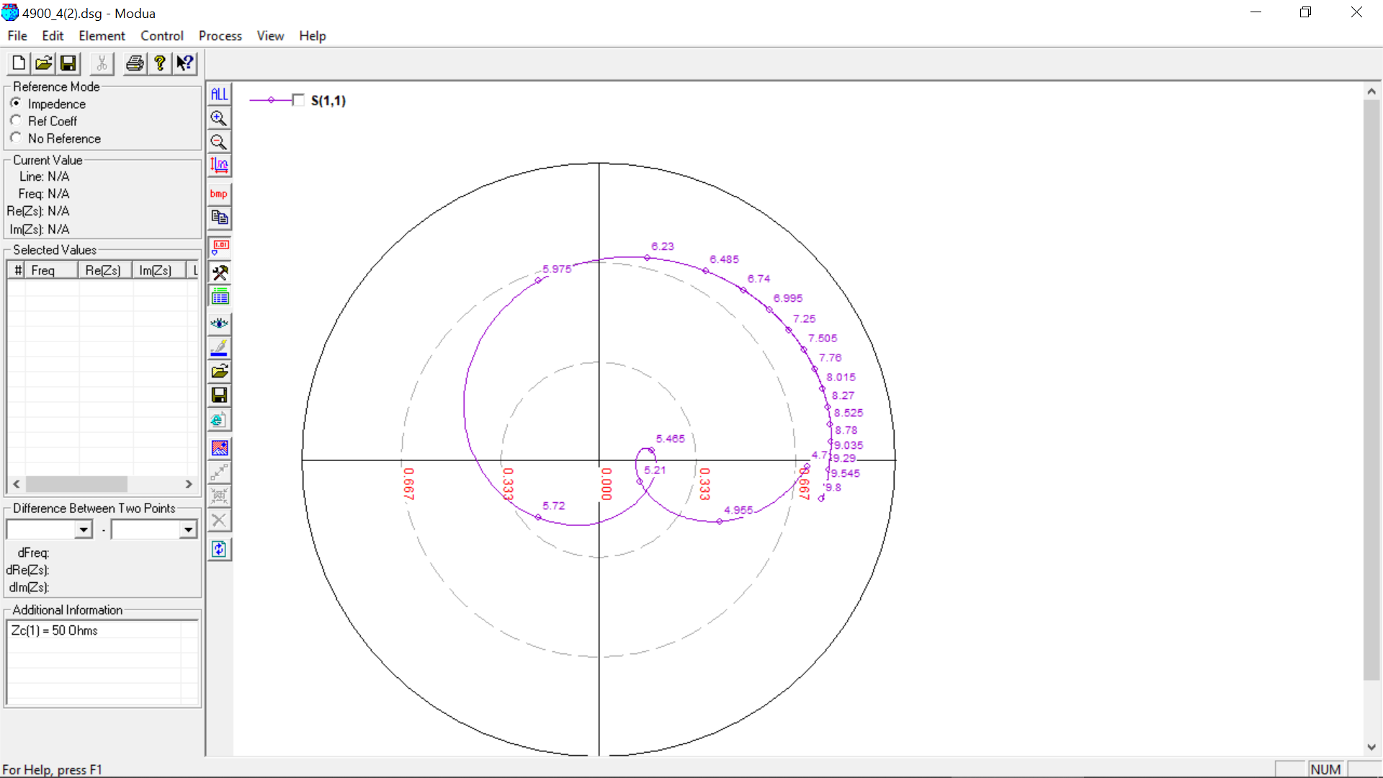

**5100 MHz, 4 (0.05 lambda)**

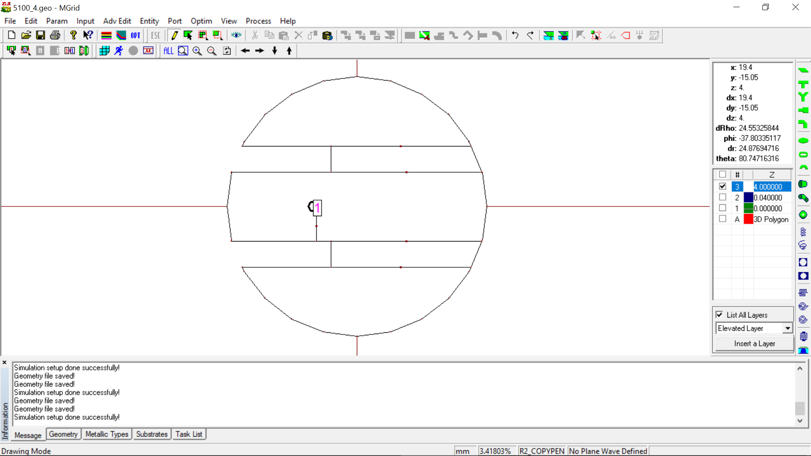

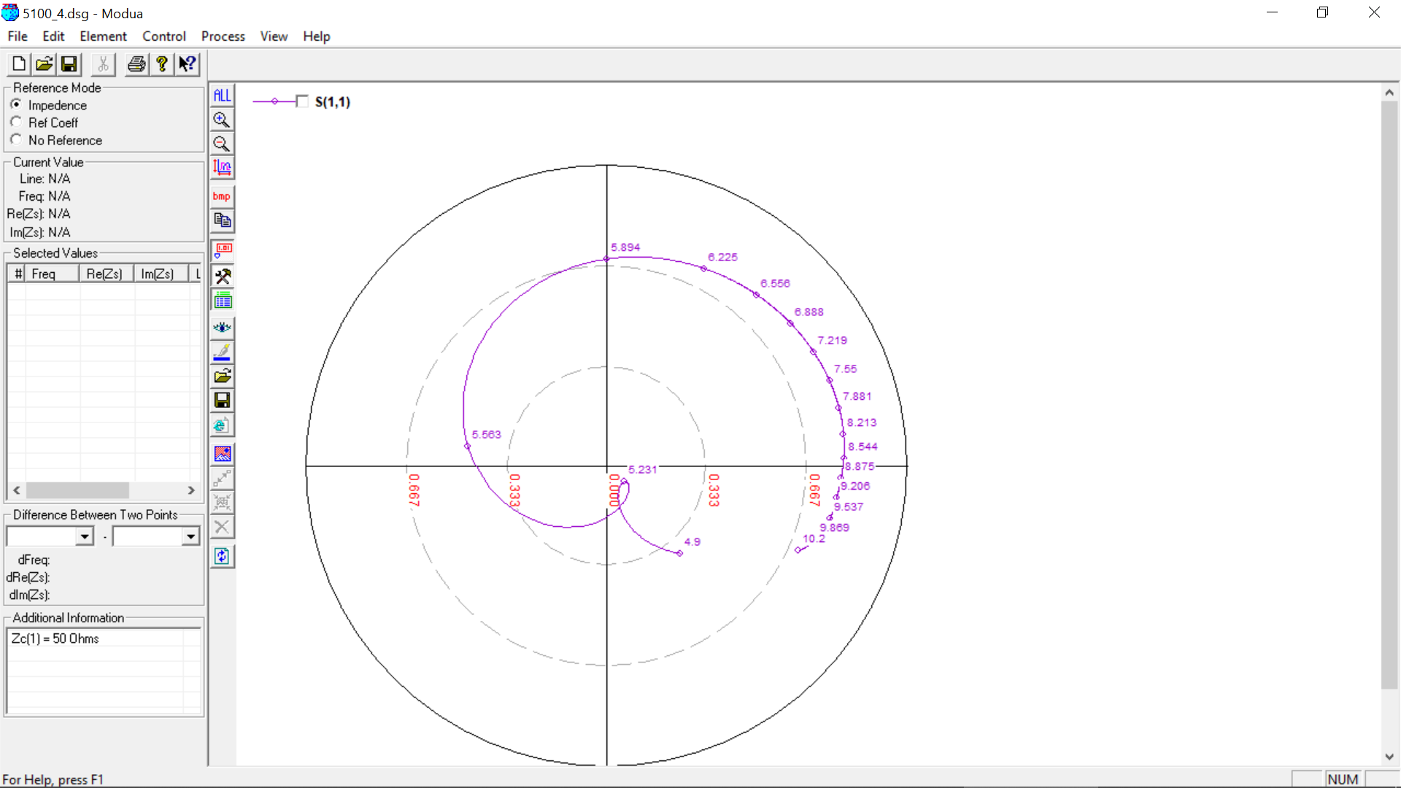

**5100 MHz, 4.5 (0.07 lambda)**

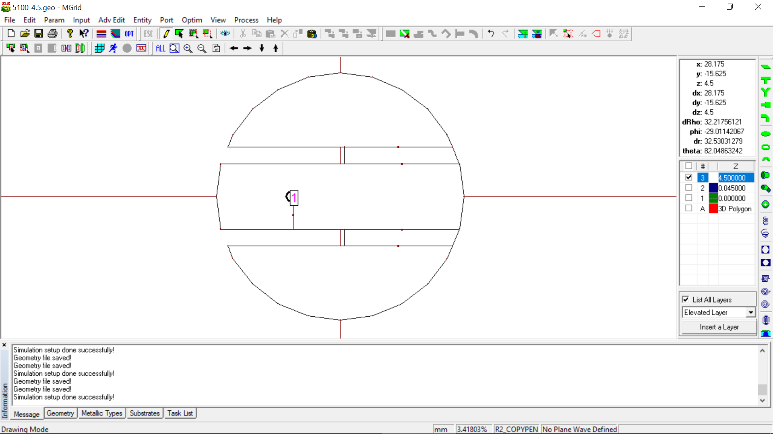

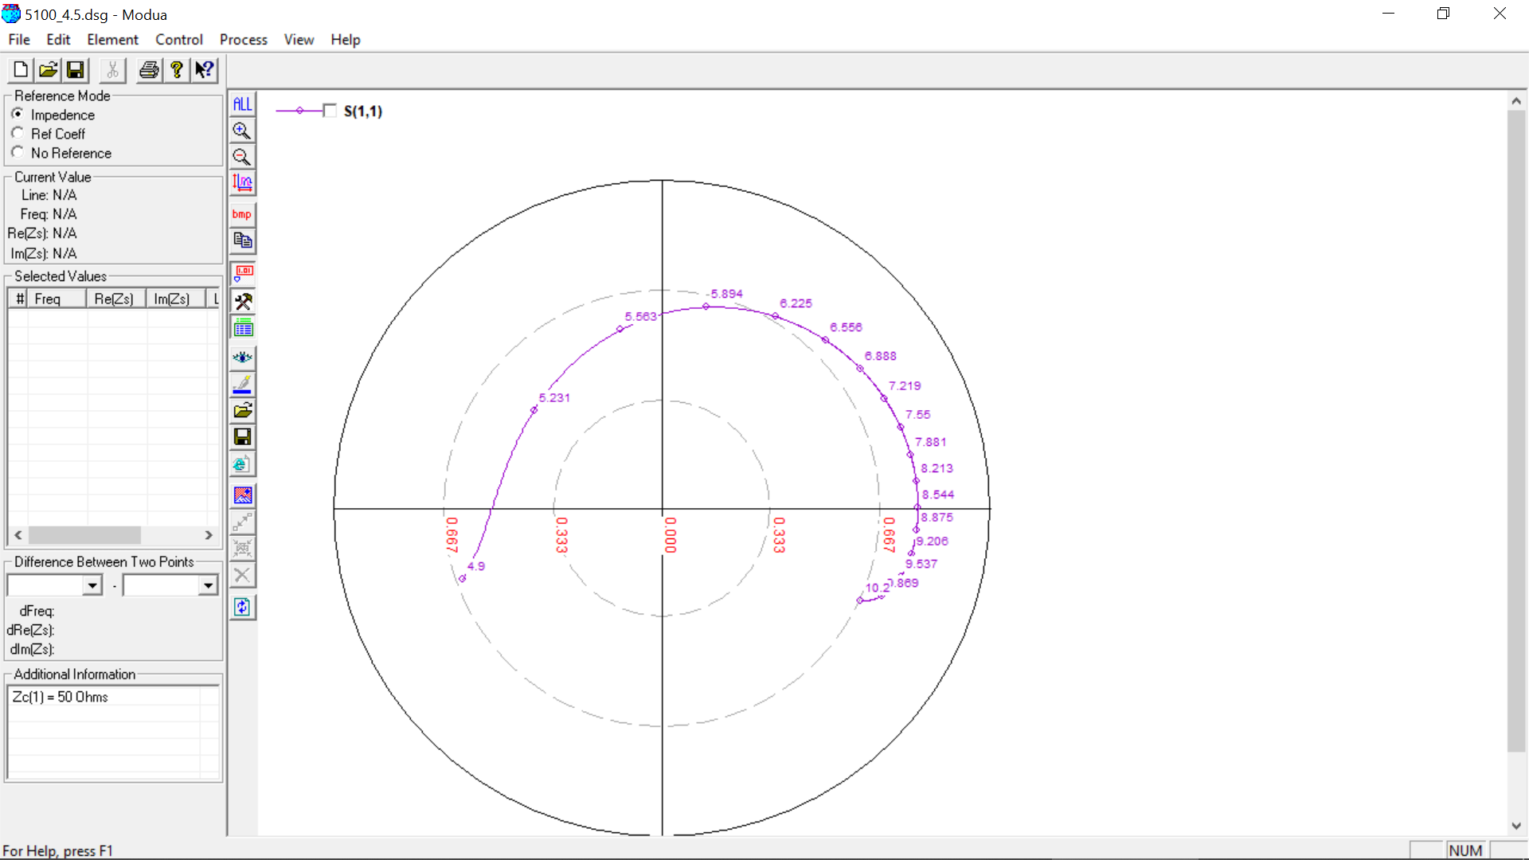

**5500 MHz, 4 (0.05 lambda)**

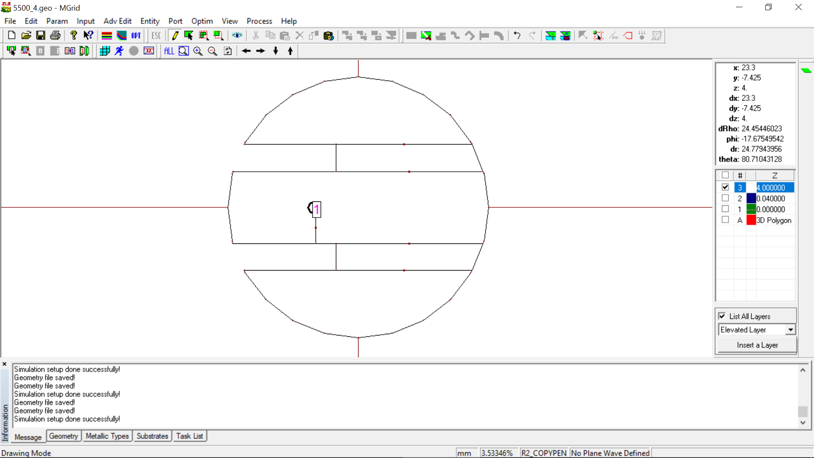

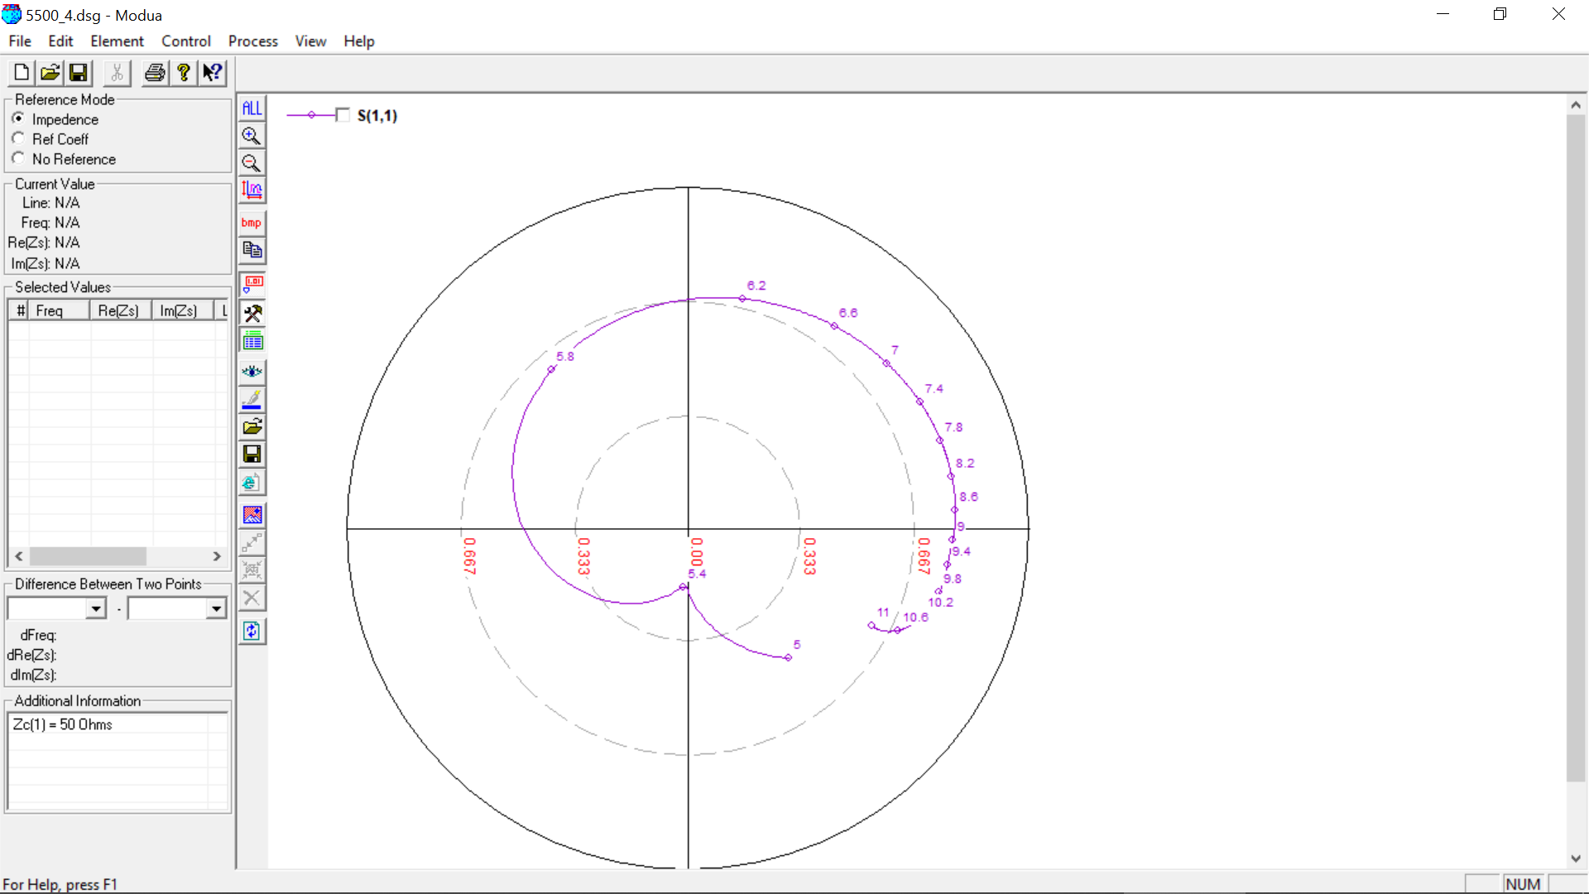

**5500 MHz, 4 (0.05 lambda) OPTIMIZED**

Initial Value: Slot Length = **12 mm**

Optimized Value: Slot Length = **11 mm**

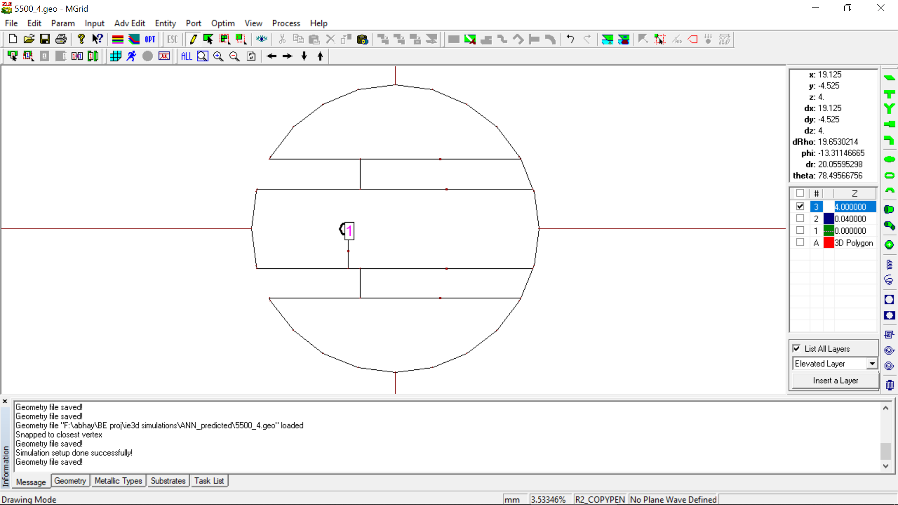

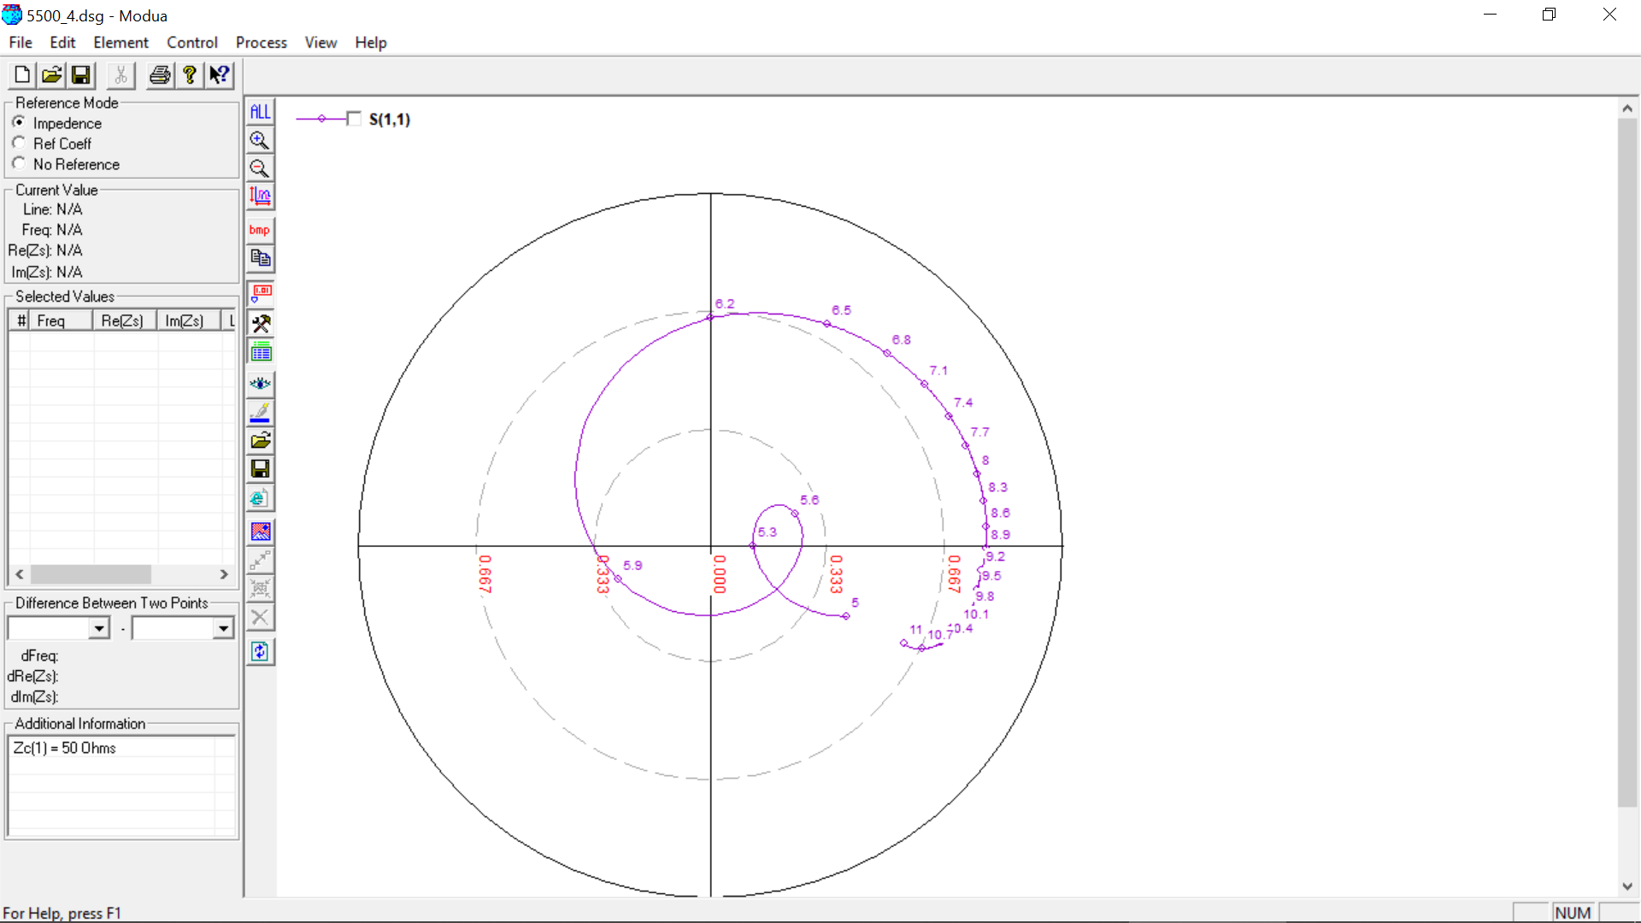

**5500 MHz, 4.5 (0.07 lambda)**

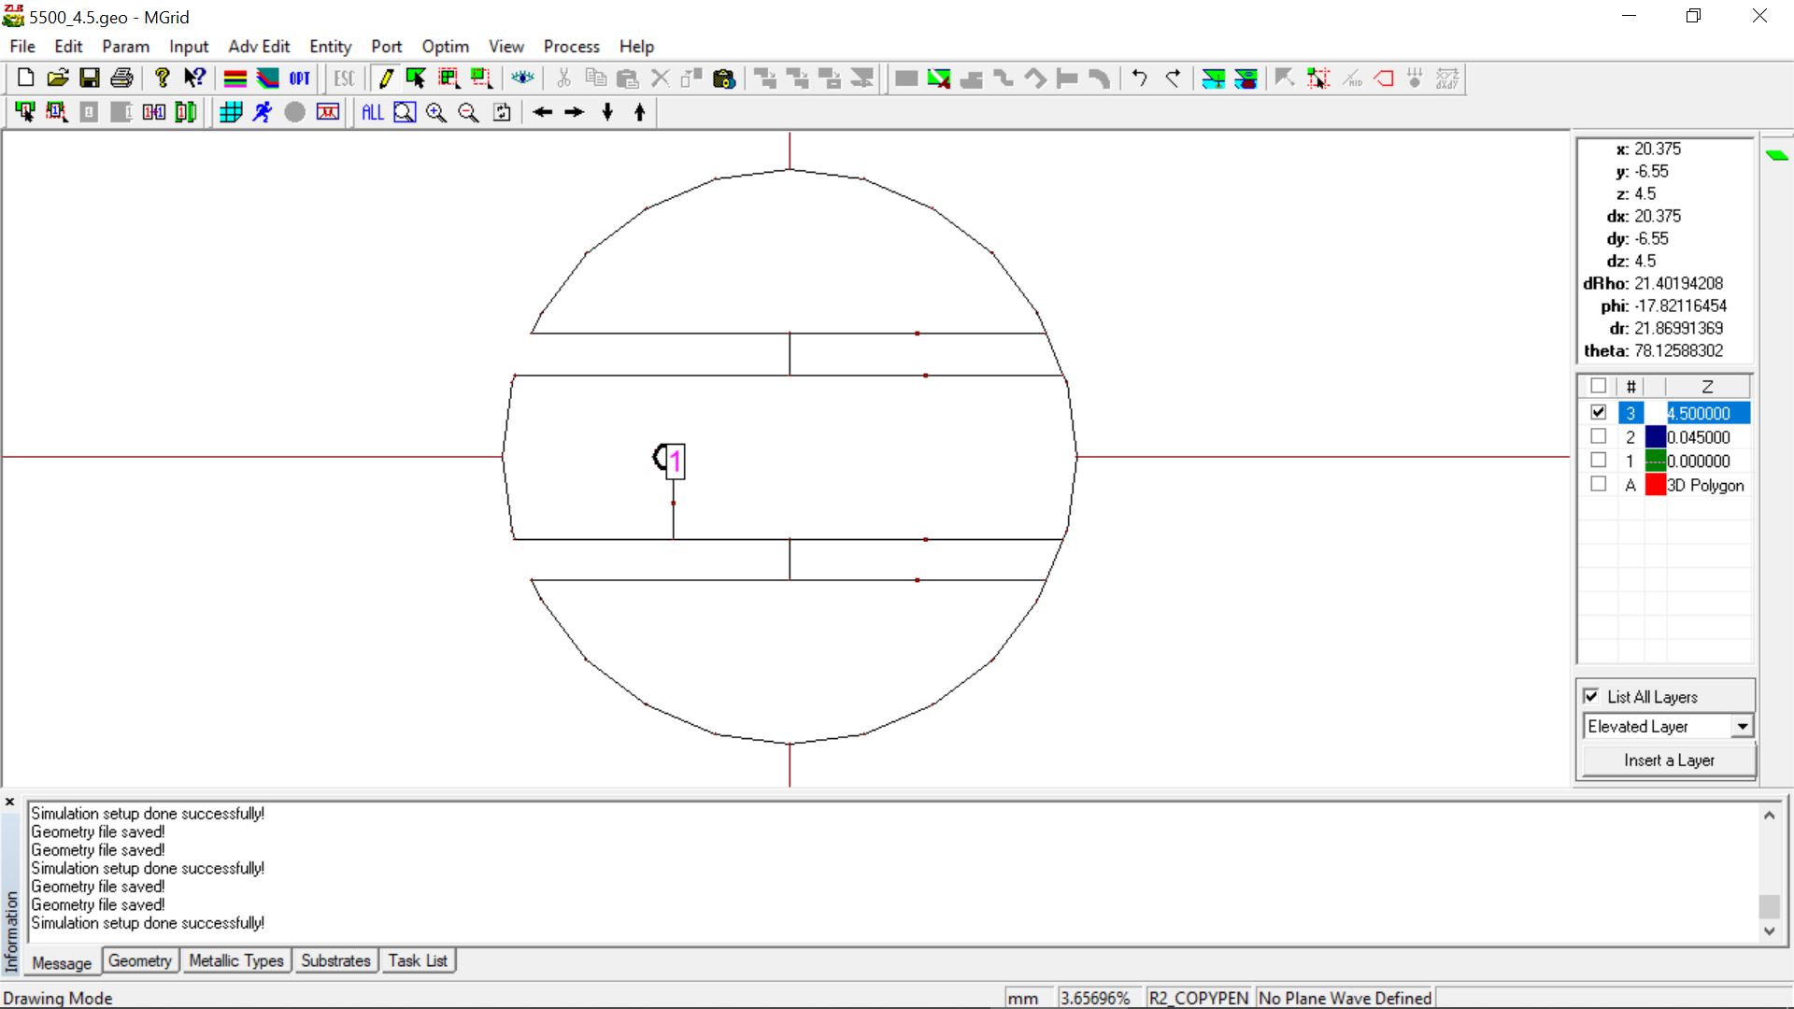

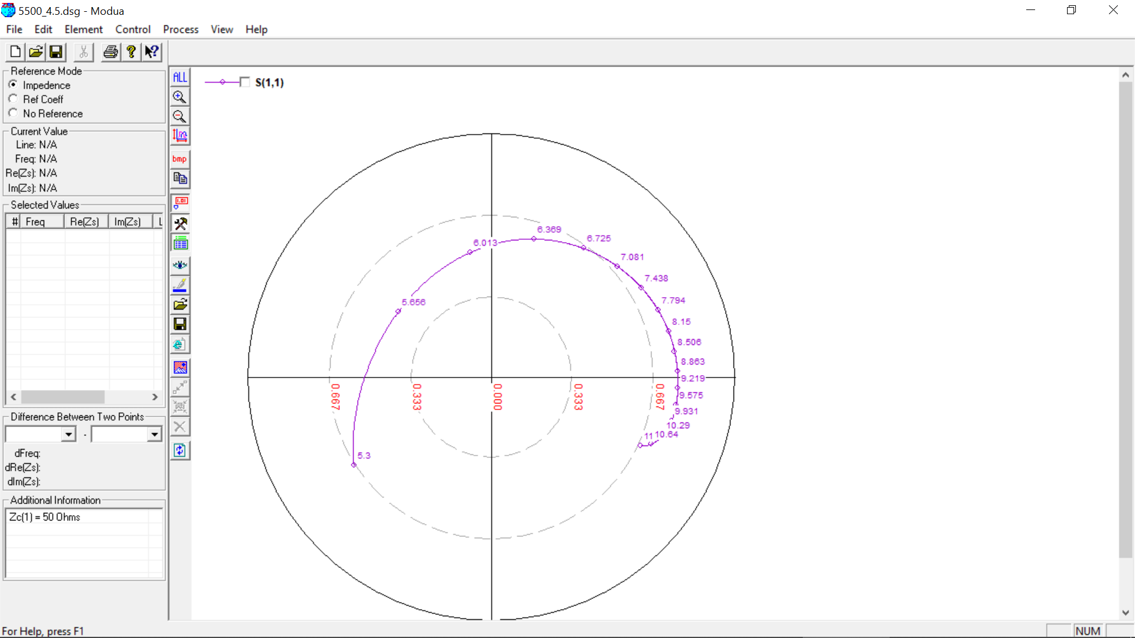

**600 MHz, 26 mm (0.05 lambda)**

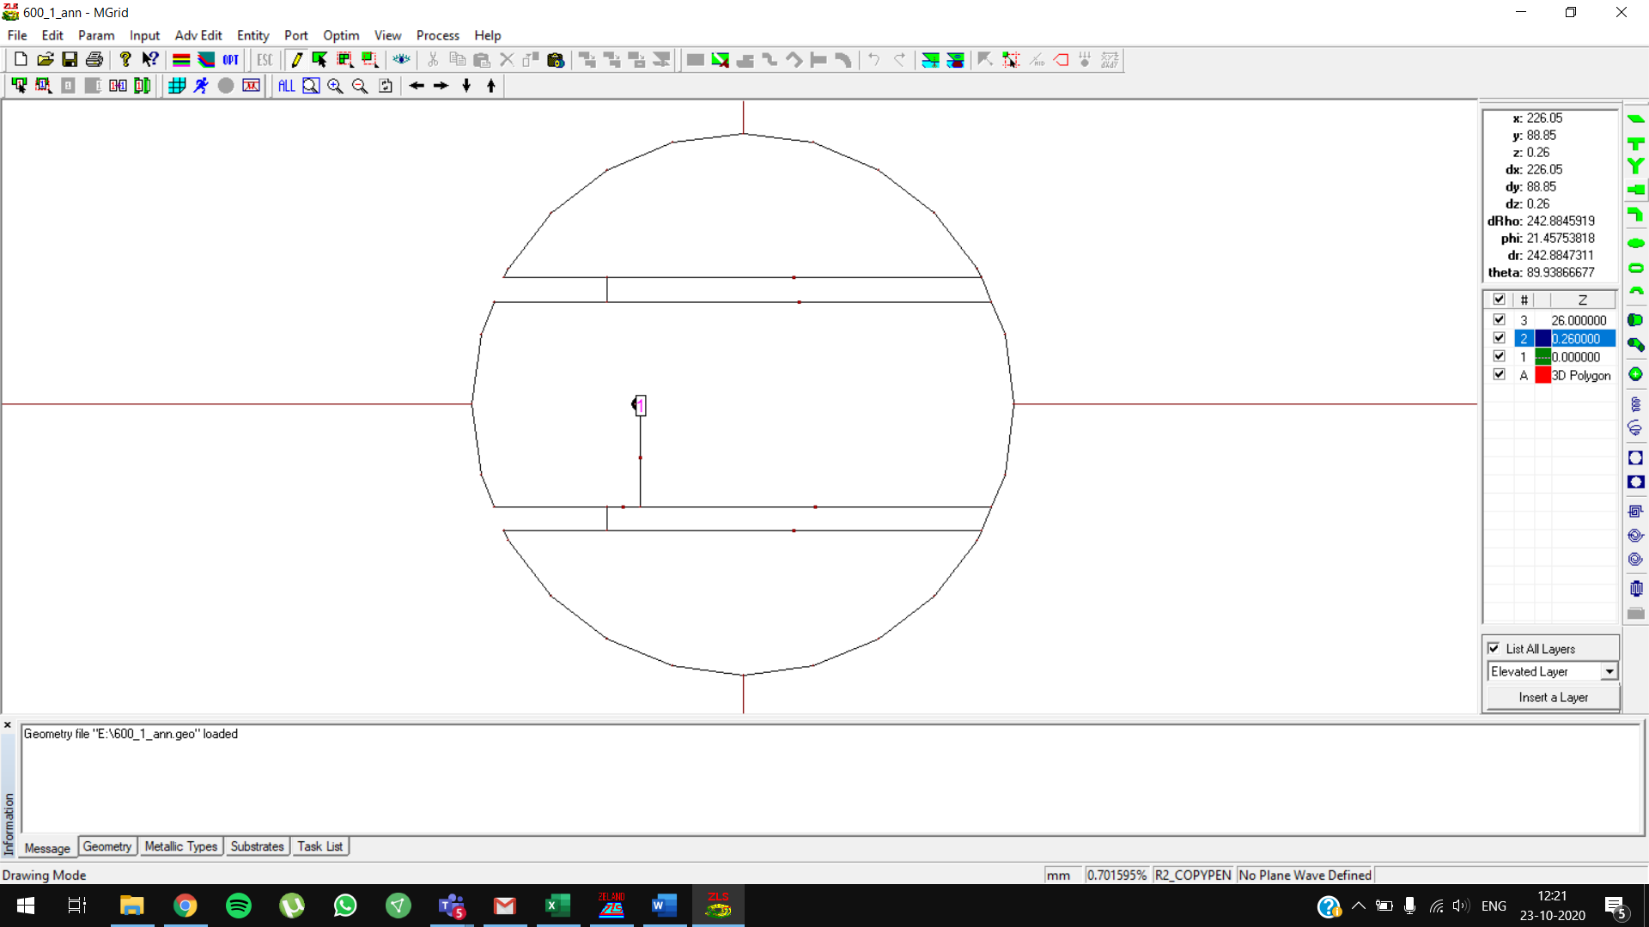

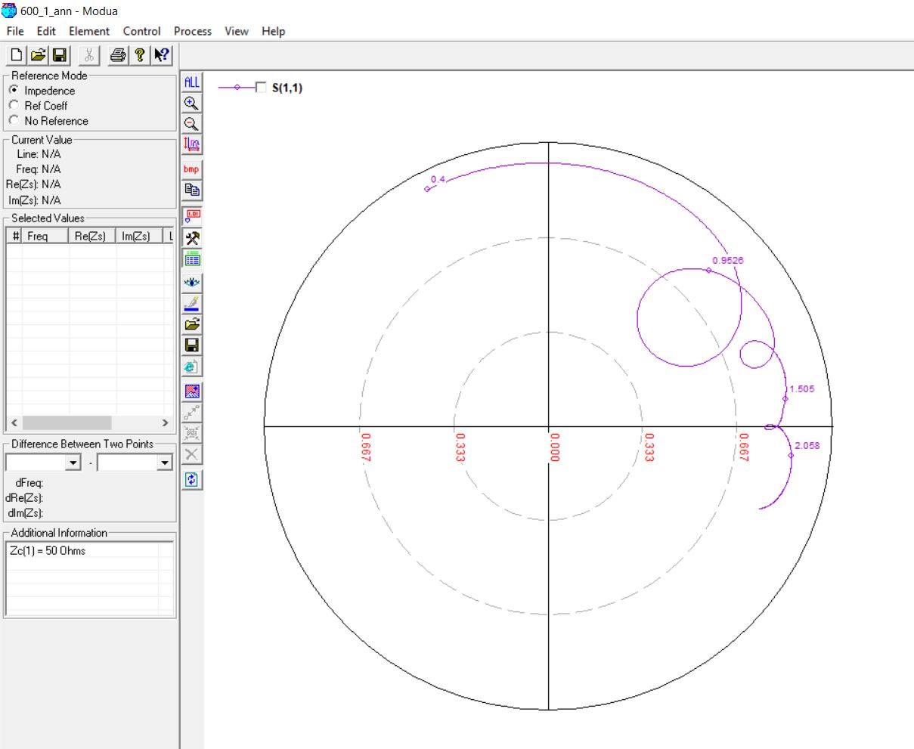

**600 MHz, 29mm (0.07 lambda)**

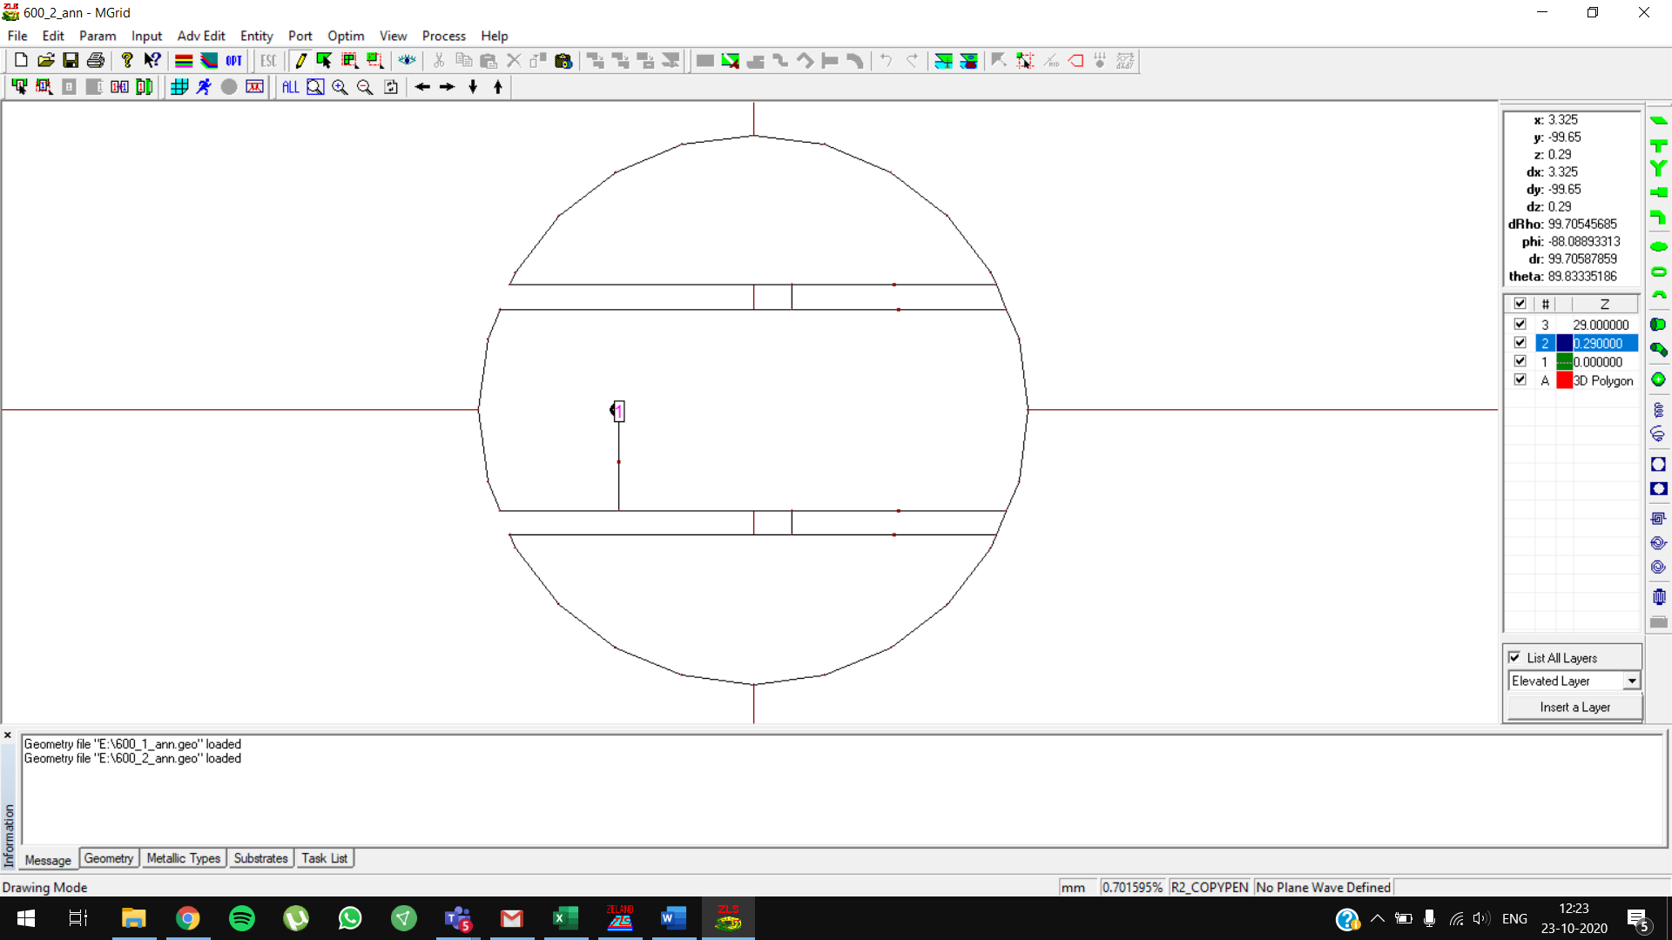

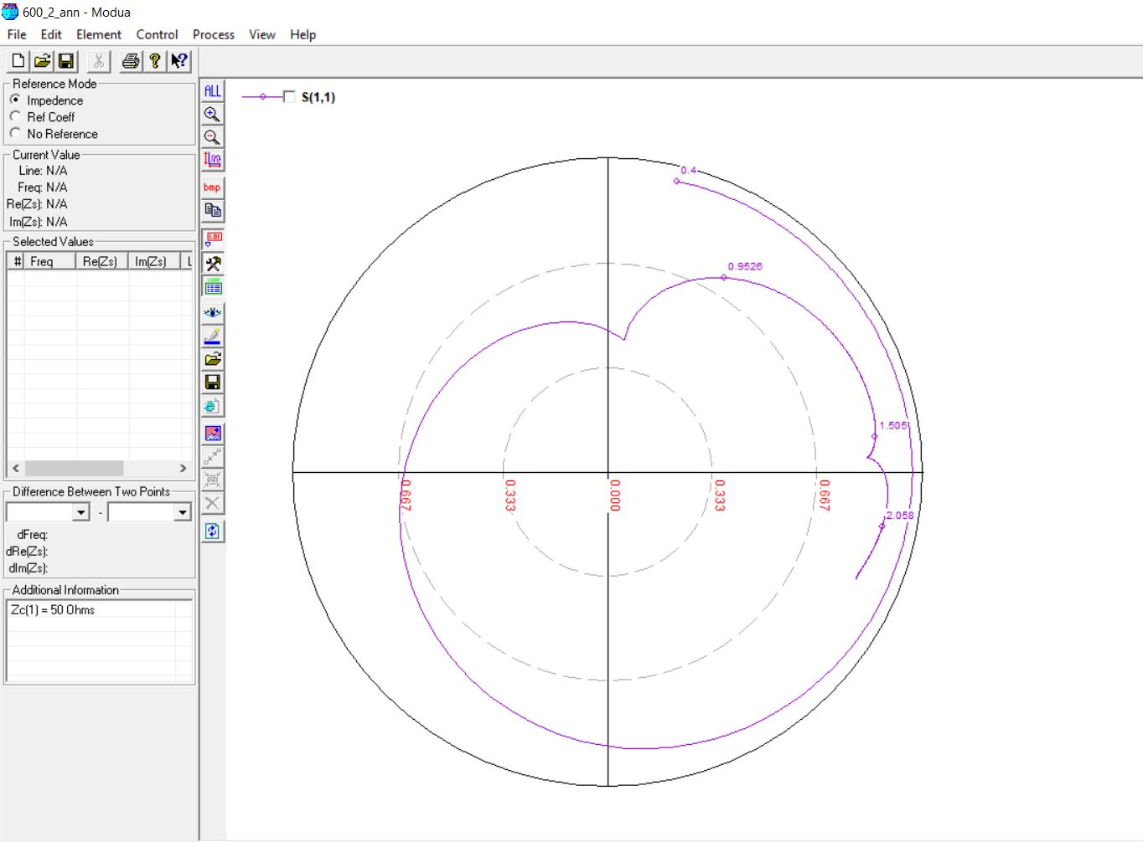

**700 MHz, 20mm (0.05 lambda)**

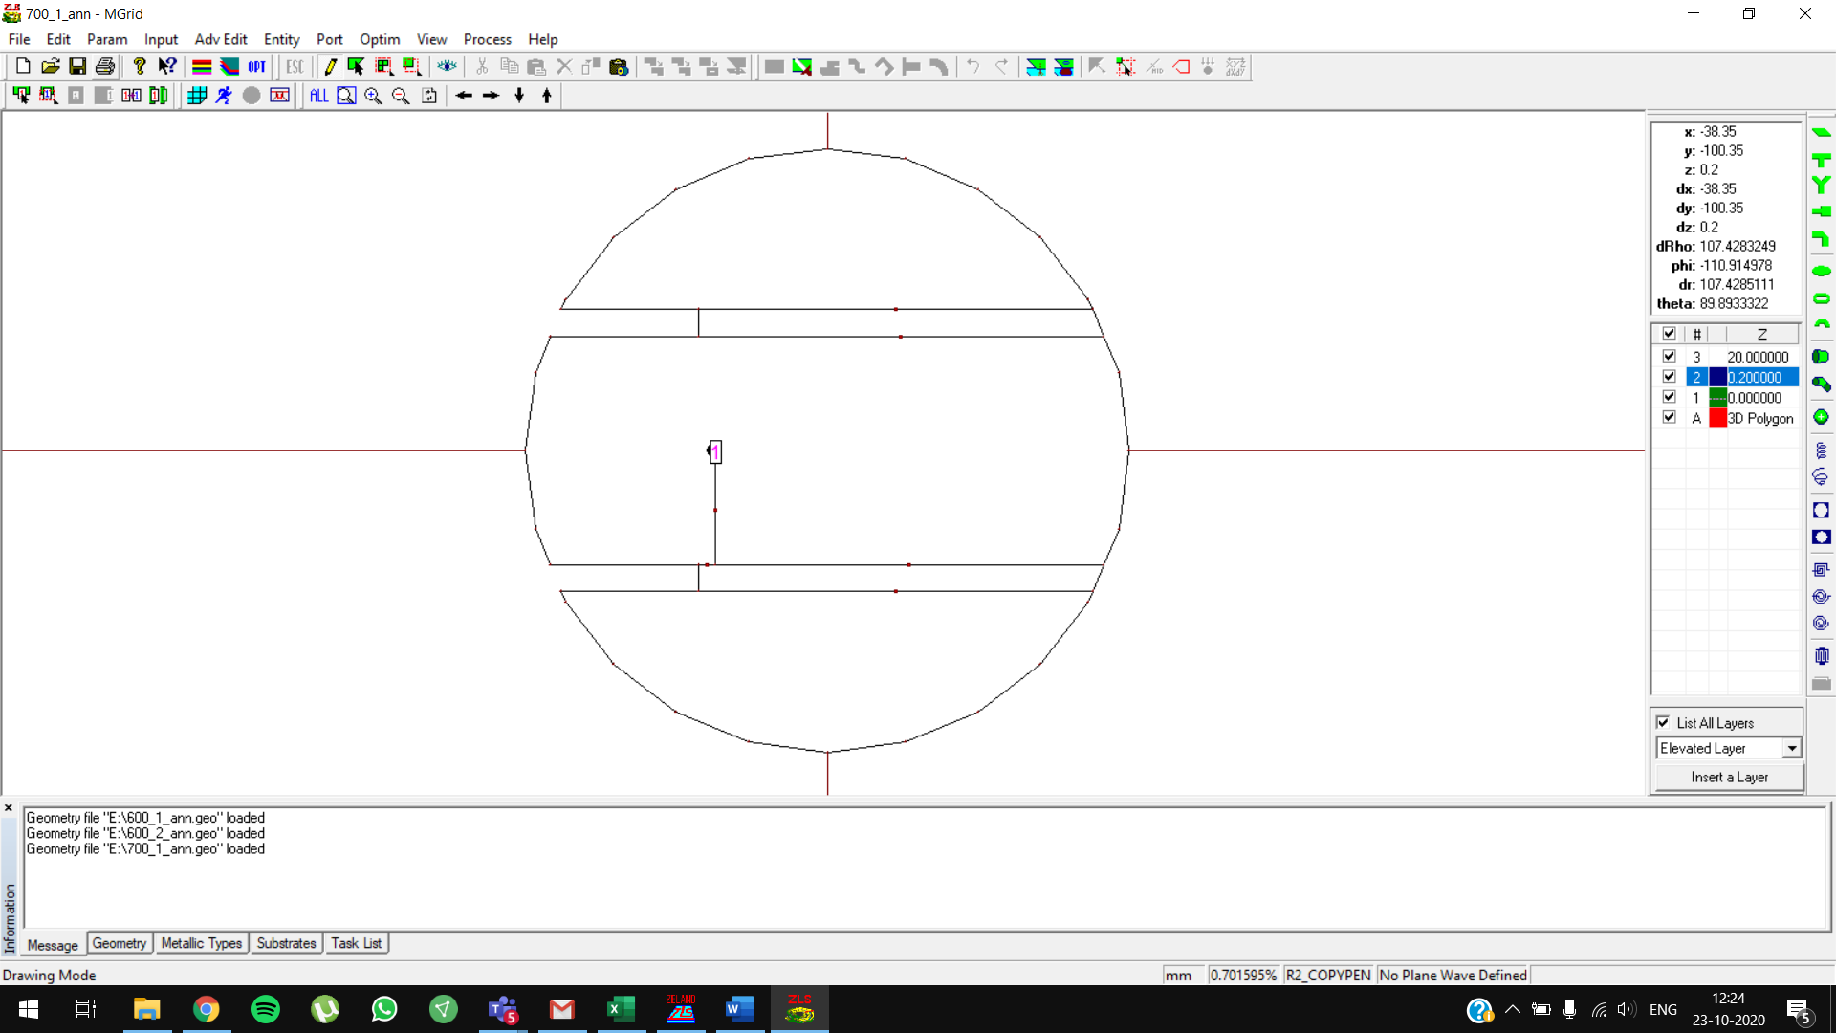

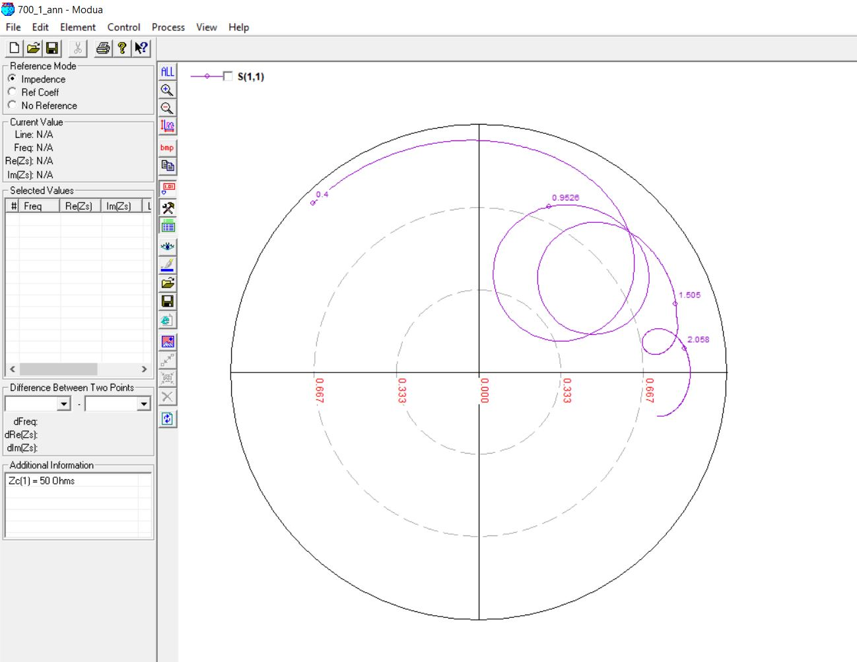

**700 MHz, 28mm (0.07 lambda)**

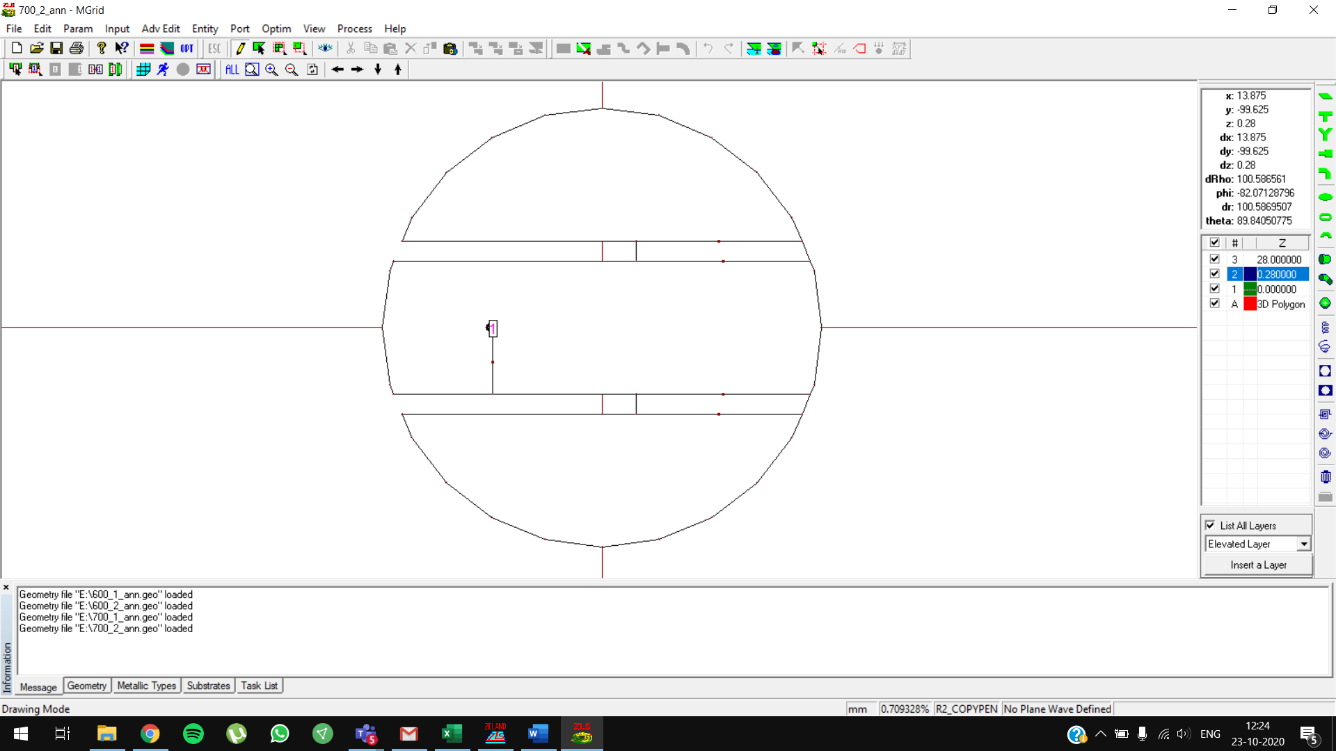

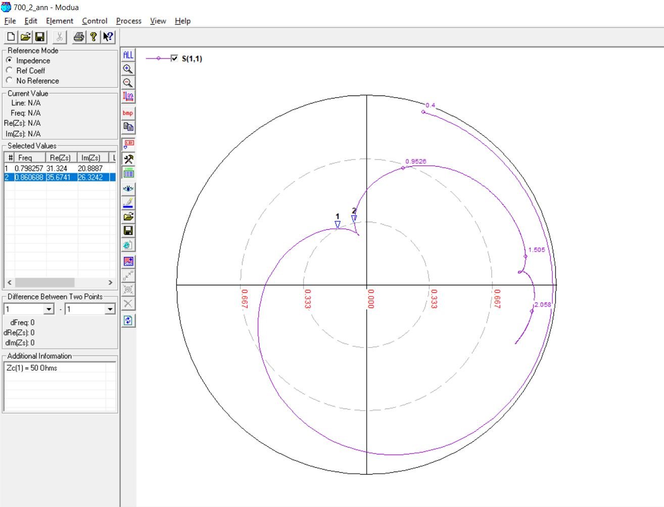

**700 MHz, 28mm (0.07 lambda) OPTIMIZED**

Initial values: feed position: **-45**

Optimized values: feed position: **-50**

